CONNECTICUT 4-H
RECORD KEEPING



SUPPLEMENTAL PROJECT RECORD
GROWTH SUMMARY
RABBIT/POULTRY Use one copy for each project animal
Animal Name/ID ______________________

Date Weighed/ Measured | Weight |  | Lbs. gained since last weigh date |  | Average Daily Weight Gain*  (ADG) |  |  |  | Comments
 |  | Total Weight Gain |  |  |  | Overall ADG*

*Average Daily Gain (ADG) is calculated by dividing the “Total Gain Since Last Weighed” by the #of days in that time period.
Rabbit/Poultry Project Growth Chart
Plot a line graph below using the size measurements from your growth chart on the previous page.

Animal Name/ID ______________________

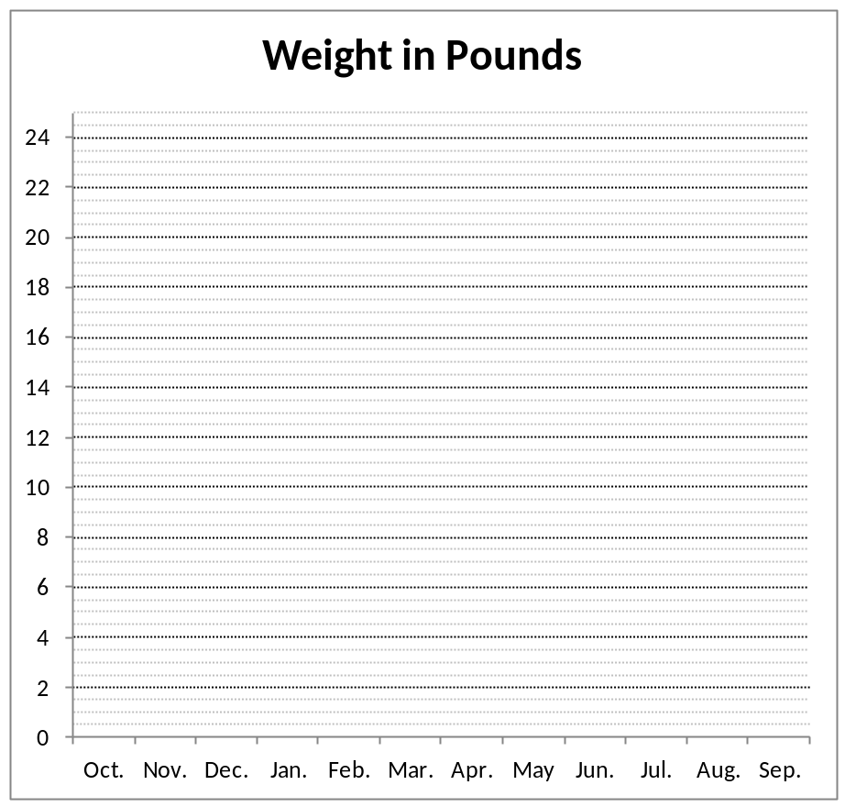

4/14

