2025 Ignite by 4-H National 4-H Summit Trip Application

The Ignite by 4-H Summit Trip is an immersive, five-day experience for 4-H members ages 13-19 where participants dive into the issues, expand your career horizons and grow as a leader while working with and learning from other teens and experts with shared passions. This combined interactive conference is being held on March 12th through March 16th, 2025, in Washington D.C. Participants will be able to choose one main track area to focus on throughout the conference, while also engaging with youth from all over the country who are attending the conference in other tracks. The three tracks available are Agri-Science, STEM and Healthy Living.

In order to attend this program, interested applicants must fill out this form, as well as the UConn 4-H Recognition form included in this document. The deadline for submitting both of these forms is October 15, 2024 to your county 4-H office.

The UConn 4-H program is offering financial support of up to two-thirds the cost of the trip. The total costs of the trip is $1200 for lodging and registration plus airfare which is estimated at $500 for a total cost of $1700. Youth participants will be required to pay $550.00. Please contact your county
4-H office for information regarding financial assistance and scholarships. Payment in full is expected by December 13, 2024.

Name:___________________________________________ Email:___________________________________

- Why are you interested in attending this conference?

- Which track (STEM, Agriscience, Healthy Living) are you most interested in and why?

- How would you share what you learned with others in your club, county or at the state level after the conference?

- Are you interested in being considered for financial support for this trip? Circle one: Yes No
Instruction Sheet for 4-H Members
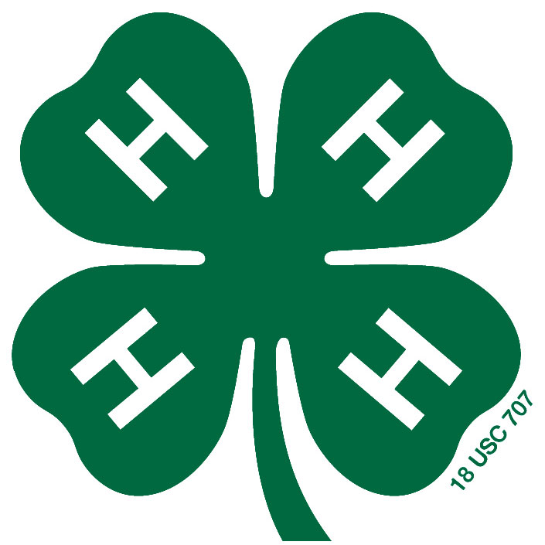

National 4-H Award Trip and
UConn 4-H Teen Council Application Process

National 4-H trips are an exciting part of the 4-H experience. To apply for selection to attend a national 4-H award trip you are required to submit a UConn 4-H Recognition Form by the required deadline and take part in an interview. Please remember that you are applying for an award that is based on your cumulative 4-H experience. Presenting a neat, thorough and complete application illustrates your interest in the award and how much effort you have put into the application process.

Completing applications are an important life experience. As you get older you will be completing applications for college, scholarships, jobs and other awards. It is important that you present yourself in a positive and professional manner. In order to make the most out of the national 4-H award trip application process here are some rules that need to be followed:
- A completed UConn 4-H Recognition Form must be submitted to the county 4-H office by the county deadline date. A completed application includes:
  - A typewritten application. Handwritten forms will not be accepted.
  - All required signatures
  - A recommendation form that is attached to the recognition form or sent separately to the county 4-H educator. Do not send recommendation forms to the State 4-H Office.
- Your county 4-H educator will review your application to make sure it is complete and will then sign it and forward it on to the State 4-H Office by the state deadline date. Incomplete applications will be returned to the applicant.
- Recognition forms will be evaluated and applicants with qualifying scores will be invited for an interview as part of the selection process.
- Qualifying applicants will be contacted by the State 4-H office to schedule their interview. Two interview dates are provided at different locations in the state. If those dates are not convenient applicants will be asked to travel to the UConn Storrs campus for their interview. Once the interviews have been completed, applicants’ scores for both their recognition form and their interview will be totaled and an average score determined for each individual.
- Applicants will be required to bring their record book to the interview. For those who do not have a record book, a minimum of an activity record sheet must be brought to the interview.
- Because you are applying for an award trip, attention will be paid to the leadership and citizenship experiences that you list on your application. Take time to think of all the leadership and citizenship activities you have taken part in throughout your 4-H career. Try to use action verbs to show that it was a leadership experience. A list of action verbs has been included with this instruction sheet. Make sure to also update your recognition form with any new activities or awards if you are applying for another trip or re-submitting your application the following year.
- Make sure to review the score sheets included with this packet for both the recognition form and the interview so you are familiar with the scoring process.
- Correct spelling and grammar are an important part of your application. Take the time to check your spelling and grammar. It’s always a good idea to have an adult review your application before you submit it because they may spot errors you have missed.
- Please remember that you can always ask your county 4-H educator to review your form or for guidance on completion of the recognition form.
8/24
2025 UConn 4-H RECOGNITION FORM & OPPORTUNITIES
The UConn 4-H Recognition Form is used to select 4-H’ers for State, Regional and National 4-H Events and other 4-H Opportunities. The form is for 4-H’ers age 14 or older. Please note that you must submit an updated form for each of the award trip deadline dates (June and October). A form submitted for consideration in October will not automatically be considered for the June award selection process. You must submit a new form even if there are no updates to it.

Due Dates to State 4-H Office (earlier due date to county office)
October 15, 2024 – National 4-H Conference (Due to county office by October 15, 2024)
June 1, 2025 – National 4-H Congress, National 4-H Dairy Conference, UConn 4-H Teen Council (Due to county office May, 2025 - check with county office for exact dates)
Name: ____________________________________________ Phone: __________________ Age: _______
Complete Address:___________________________________________________________________________
Club Affiliation: _____________________________________ E-Mail: _______________________________

2025 State Recognition Form Opportunities (Please check activity you want to be considered for)
 National 4-H Conference, Washington, D.C., (April 11-16, 2025). Must be 15-18 years old on January 1 of
the current conference year to participate. https://4-h.org/parents/national-4-h-conference/
 National 4-H Dairy Conference, Madison, Wisconsin (Dates TBA) https://national4hdairyconference.org/
Must be at least 15 but not more than 18 years of age before January 1 of the conference year to participate. Open to dairy goat project members.
 National 4-H Congress, Atlanta, Georgia (Nov. 28-Dec. 2, 2025) http://www.national4-hcongress.com/
Youth attending must be at least fourteen and not more than nineteen on January 1st of the year that they attend National 4-H Congress.
 UConn 4-H Teen Council (Application deadline June 1, 2025) Open to 4-H members ages 14-18.

National 4-H Trip Opportunities
Citizenship Washington Focus – UConn 4-H will participate in this event in 2026. CWF participants enjoy a behind-the-scenes look at our nation’s capital and the chance to meet members of Congress; motivational speakers, educational workshops, and assemblies that increase individual commitment to citizen involvement and build lifetime skills for success; activities that encourage new and lasting friendships; and an enthusiastic staff of young adults that work directly with them.

National 4-H Conference is a working conference in which delegates explore current issues affecting youth and the role 4-H can play in addressing those issues. Each youth chooses their topic before they arrive for conference. During the conference, youth develop a presentation on their findings/discussions to share with a federal agency’s key decision makers. This event also includes Capitol Hill visits along with monument tours and other social activities.
National 4-H Dairy Conference provides an opportunity for youth to meet with members of the dairy industry and develop a better understanding of the production and marketing of dairy products as well as provide a broad understanding of careers available in the dairy industry. A variety of tours and workshops are offered to meet these objectives.

National 4-H Congress - National 4-H Congress is a pinnacle event of the 4-H experience providing workshops focused on the 4-H mission mandates, hands-on service-learning experiences, challenging speakers, and opportunities for networking and recreational activities.

UConn 4-H Teen Council -Applications for the 2026 4-H year will be due June 1, 2025. Interviews will be scheduled through September of 2025 and the term will run from October 1, 2025 to September 30, 2026.

UConn 4-H
RECOGNITION FORM


Name:
As it appears on driver’s license or other form of identification

Address

Town____________________________________ Zip Code_________________

Phone ( ) Age ________ Birth date ___/___/___ Grade _____

Male______ Female______

Youth Cell Phone: Parent Cell Phone:

Youth Email Address

Parent Email Address

Years in 4-H ______________________________________________
Affiliation – Name of Club or Individual Member

Major 4-H projects________________________________________________________

STATEMENT BY 4-H MEMBER

I personally have prepared this report and certify that it accurately reflects my work:

Date_______________ Signed: _______________________________
(4-H Member Signature)

APPROVAL OF THIS REPORT

We have reviewed this report and believe it to be correct:

Date_______________ Signed:_____________________________________________
(Parent or Guardian)

Date_______________ Signed:_____________________________________________
(Local 4-H Leader)

Date_______________ Signed:_____________________________________________
(Extension Educator)

Information reported should reflect the highlights of your 4-H involvement. Non 4-H activities should be listed under Question 4.

- Leadership Activities – List and describe your leadership experiences in 4-H. Include elected, appointed or volunteer offices held (Fair Association, club officer, committee chair, etc.) and what your responsibilities were in those positions. What did you accomplish while in these positions? (i.e., helped to plan, organize, or conduct particular events or activities)

- List Leadership Activities
Activity Level of Participation* Year(s)

- Describe Leadership Activities (Write a brief paragraph about your
accomplishments in those positions)

*Level of Participation – Did you participate, help plan, implement, etc.
- Citizenship Activities – List your citizenship/community service experiences and team cooperative efforts in 4-H. Include things that contribute to the welfare of your group members, other individuals, your community or things which have helped your club or group work more effectively.

- List Citizenship Activities
Activity Level of Participation Year(s)

- Describe Citizenship Activities - (Write a brief paragraph about your
accomplishments in those positions.)

- Public Presentations – Describe your public speaking activities in 4-H. Include presentations in club and community, participation in Public Speaking programs, speaking before groups, appearances on radio and TV, Master or Mistress of Ceremonies, doing a working booth, or other participation.

4. Other Activities – List other 4-H projects/activities. You can also include other
community, church and school activities if applicable.

- Please describe why you would like to be considered for participation in a state award trip or
Citizenship Washington Focus Program, and what contributions you could make to
4-H based on your participation in such a program afterwards.

- 4-H Story: Use additional pages to write your 4-H Story. Your story should be no more than five pages. Consider the following questions when writing your story:

- How has 4-H impacted your life?
- How have you benefited from the setting and attainment of specific goals?
- What rewards have you experienced as a result of your leadership and citizenship experiences in 4-H?
- What problems have you discovered as a result of these experiences?
- What do you need to do or learn to improve your leadership abilities?
- How might the skills, knowledge and leadership abilities you gained through 4-H benefit you and others in the future?

UConn 4-H RECOGNITION RECOMMENDATION

Recommendation to be submitted by someone other than a relative.

The UConn4-H Recognition Form is being submitted in order to consider _______________________ for 4-H state awards (trip to Citizenship Washington Focus, National 4-H Congress, National 4-H Conference, National Dairy Conference, etc.).

Please write a statement explaining why this 4-H member should be considered for the recognition requested. Include things like quality of work, attendance, motivation, what you have observed he or she has learned and leadership ability. Please be specific. State actual events where applicant exhibited behaviors that qualify him or her for this award.

Date__________________

Printed Name:________________________________________

Signature:___________________________________________________________
(Relationship to Applicant)

Please return completed form to your county 4-H Educator
The University of Connecticut complies with all applicable federal and state laws regarding non-discrimination, equal opportunity and affirmative action, including the provision of reasonable accommodations for persons with disabilities. UConn does not discriminate on the basis of race, color, ethnicity, religious creed, age, sex, marital status, national origin, ancestry, sexual orientation, genetic information, physical or mental disability, veteran status, prior conviction of a crime, workplace hazards to reproductive systems, gender identity or expression, or political beliefs in its programs and activities. Employees, students, visitors, and applicants with disabilities may request reasonable accommodations to address limitations resulting from a disability. Contact: Office of Institutional Equity; 860-486-2943; equity@uconn.edu; https://www.equity.uconn.edu

UConn 4-H Recognition Form Score Sheet

Name of 4-H Member_______________________________________________________

Name of Evaluator__________________________________________________________

Date_________________

Please complete this score sheet for each individual recognition form. Place the appropriate rating next to each category listed below. The total number of points allowed for each category is listed next to the category title.

________ Content (25 points): This includes overall experience in the 4-H program.

________ Leadership/Citizenship (25 points): Sections 1 and 2 of the Recognition Form

________ 4-H Story (25 points): Story should be no more than five pages and should
address how 4-H has impacted the author’s life.

________ Correctness/Completeness (20 points): The form should be neat and easy to
read. Spelling and grammar are important

________ Recommendation (5 points): Recommendation form completed by individual
other than relative must be attached to recognition form.

________ Total Score

General Comments:_________________________________________________________

_________________________________________________________________________

_________________________________________________________________________

_________________________________________________________________________

Interview Score Sheet

Name of 4-H Member_______________________________________________________

Name of Evaluator__________________________________________________________

Date_________________

Please complete this score sheet for each interview. Place the appropriate rating next to each category listed below. The total number of points allowed for each category is listed next to the category title.

________ Appearance (5 points): Wore clean, wrinkle-free clothes, hair combed, clothes were appropriate for interview.

________ Entrance/Exit (5 points): Used a friendly greeting and introduces self by name. At end of interview thanks interviewers.

________ Body Language (10 points): Maintained good eye contact and used good posture. Does not display nervous or distracting gestures.

________ Responses to Questions (40 points): Answered questions directly and completely.

________ Language Used (15 points): Used complete sentences, enunciated words correctly.

________ Questions Asked (5 points): Asked relevant questions of interviewer.

________ Interest (15 points): Expressed strong interest in the award/activity. Showed appropriate excitement.

________ Preparation (5 points): Applicants must have their record book available during the interview. For those who do not have a record book, a minimum of an activity record must
be brought to the interview.

________ Total Score

General Comments:________________________________________________________

________________________________________________________________________

________________________________________________________________________

CHOOSING ACTION VERBS
Below is a list of action verbs. Use these verbs to describe duties you have performed in jobs, projects, or volunteer experiences. Using these words will strengthen your application or resume.

Ordered Planned Administered
Examined Compared Inspected
Arranged Developed Exhibited
Weighed Recorded Addressed
Mapped Memorized Protected
Recruited Edited Formed
Judged Informed Budgeted
Purchased Summarized Tested
Operated Wrote Defined
Selected Monitored Gathered
Eliminated Drew Collected
Enforced Photographed Designed
Improved Scheduled Interviewed
Painted Built Cleaned
Loaded Devised Harvested
Fixed Sewed Drove
Typed Chose Charted
Solved Supplied Studied
Organized Mentored Taught
Conducted Evaluated Implemented
Coordinated Applied Possessed
Compiled Determined Drafted
Counseled Delegated Delivered
Demonstrated Described Enlisted
Established Executed Explained
Furnished Utilized Trained
Supervised Solicited Served
Reviewed Reported Recognized
Provided Produced Presented
Prepared Performed Identified
Initiated Maintained Managed
Modified Interpreted

