
New London County 4-H
Public Presentation Program
New London County Extension Center
Norwich, CT
February 7, 2025, 6:30 p.m.
- All New London County 4-H members are encouraged to register for this county event.
- Teams are allowed to move onto the Level II state contest if they qualify at the county level.
- Novice (7–8-year-olds). Novice will compete in the county (Level 1) only.
- The County Qualifying (Level I) contest will be judged Danish system, every contest using the same rubric, and Danish ribbons awarded (Blue, Red, and White).
- All Senior and Junior Blue-Ribbon winners from Level I can move on to the Level II State qualifier. This contest will be virtual. You can choose not to continue if you wish.
- The top 4 scorers in each category from Level II will continue to Level III State Finals. That contest will be in person.
- Remember, you are NOT competing against each other. You are competing against the scoring rubric.

The NLC 4-H Public Speaking Registration 2025 Form is open now to register for the county contest.
Call 860-885-2824 or email marc.cournoyer@uconn.edu if you have any questions. ☺

PUBLIC SPEAKING AGE DIVISIONS
Explorers- any youth who are in an Explorers Club
Novice- any youth 7-8 years old as of January 1
Juniors- any youth 9 – 12 years old as of January 1
Seniors- any youth 13 – 19 years old as of January 1

CATEGORIES
- Explorers- “Show and Tell”, not scored (1-3 minutes, at county contest only)
- Novice Public Speaking- note cards only (3-5 minutes, at county contest only)
- Novice Presentations- demonstration, illustrated talk using any prop, music, or costumes, power point or computer presentation (3-5 minutes, at county contest only)
- Jr. Public Speaking- note cards only (3-5 minutes)
- Jr. Presentations- demonstration, illustrated talk using any prop, music, or costumes, power point or computer presentation (3-5 minutes)
- Sr. Public Speaking- note cards only (5-8 minutes)
- Sr. Presentations- demonstration, illustrated talk using any prop, music, or costumes, power point or computer presentation (5-8 minutes)

PUBLIC SPEAKING DIVISIONS
Speeches- note cards only – involves talking about something of interest to you without the use of any other aids. The speech can be informative or argumentative. No props are used during the speech.
Presentations
- Demonstration – involves doing something (making, creating, finishing, etc.) while talking about what you are doing. This is usually the easiest type of presentation. First time participants are encouraged to do a demonstration.
- Illustrated Talk – involves talking about something while using an illustration such as a diagram, chart, model, or picture. This can also include using costumes, music, or any type of prop.
- Electronic Media - A demonstration or illustrated talk that uses computer technology.
For Power Point presentations a screen, laptop, and LCD projector are provided. All presentations must be emailed to Marc (marc.cournoyer@uconn.edu), by the close of business the Wednesday before the contest, so the presentations can be loaded onto the laptop. PowerPoint presentations must be PC compatible. Remember to have an alternate plan for your presentation in case the technology fails (you can bring your own laptop or USB drive).
Team Demonstrations are available for any age group. A team is TWO people. Both participants must have an equal role in the presentation.
- Teams can now qualify to move onto state level contests if they achieve a blue ribbon at the county contest.
- Team members must be in the same age bracket to qualify. No mixed age teams will move onto state contests.
- Must be 9 years or older to qualify for state level contests.
Explorers- Explorers will participate much like a “Show & Tell.” They are not judged or timed, although a speech/demonstration of 1-3 minutes is appropriate. Explorers participate at the county level, not at the state contests. They receive the green participant ribbons. It is helpful for them to receive positive, encouraging feedback on the approved Explorers Commentary Card.

REGISTRATION
Everyone must pre-register to participate. No day of registrations will be allowed.

EVALUATION
- All youth will be judged on a point score sheet–4-H’ers with scores of 90-100 will move on to the next level of competition. All youth will receive their evaluations with comments at the end of each contest.
- Each Blue-ribbon winner from Senior and Junior divisions will go on to the State Level II contest to represent New London County. Novice, and Explorers are not eligible for state competition.

HORSE PUBLIC SPEAKING
The state 4-H Horse Program made the decision in 2024 to incorporate the state horse public speaking opportunity into the regular 4-H public speaking contests. To qualify for the Eastern National Roundup in Kentucky youth must:
- Be at least 14 years of age by January 1, 2025
- Present on a horse related topic
- Qualify and compete at all 3 contest levels in a recognized division and achieve a blue ribbon at state finals

STATE 4-H PUBLIC SPEAKING CONTEST
The State 4-H Public Presentation Level II Contest will take place on February 26 & 27. All County level Blue Ribbon winners will compete virtually in their divisions. The top 4 youth in each division will move on to the state finals, held at the UConn campus in Storrs on Saturday, March 8 in person. You will get information on the next level contests from Marc Cournoyer at marc.cournoyer@uconn.edu and/or Emily Picard at emily.picard@uconn.edu.

Information, forms, and handouts are available on-line as well. Look under County Programs.


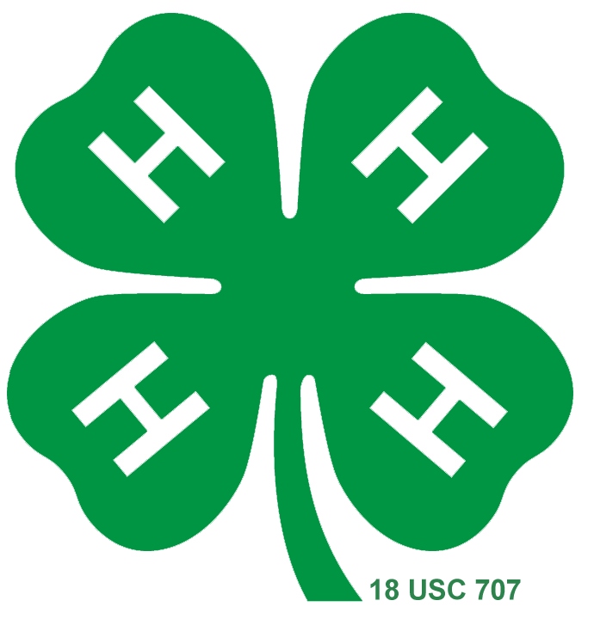

UConn complies with all applicable federal and state laws regarding non-discrimination, equal opportunity, affirmative action, and providing reasonable accommodations for persons with disabilities. Contact: Office of Institutional Equity; (860) 486-2943; equity@uconn.edu; http://www.equity.uconn.edu.

