UConn 4-H Fairfield County Dog Show

## Saturday June 28, 2025

**Obedience Dog Training Club of Waterbury, 11 Robinson Lane, Oxford, CT**

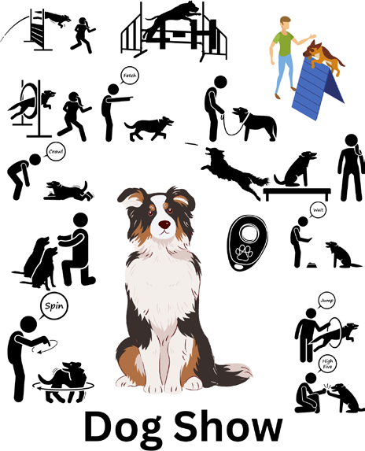

**Cover contest winner- Leyah Cupole**

This year’s dog show is generously sponsored by Pleasant Paws Pet Center, Newtown, CT

UConn Extension Logo

**Bronze Sponsor of Fairfiel County 4-H 
Promotional poster for Pleasant Paws Pet Center, showcasing luxury pet care services including boarding, grooming, and training options.**

**Diamond Sponsor of Fairfield County 4-H**





# FAIRFIELD COUNTY 4-H

***where youth***

# DREAM and ACHIEVE

SPECIAL THANKS

to the

**Julia Wassermann Animal Welfare Fund**

for their Generous Support of Our

Animal Related Projects!

*4-H- Making the Best Better*

**e are a 4-H Youth Club that focuses on science, engineering, and 
technology in the robotics community. Our aim is to teach our youth life 
skills, leadership, and responsibility for the future with advances in 
robotics sciences.

PowerSurge 4-H Robotics, team # 2712, is 1 of 55 FIRST Robotics Competition teams in CT. 
FIRST Robotics Competition (FRC) is an international high school robotics competition. Each year, teams of high school 
students, coaches, and mentors; under strict rules with limited time and resources, are challenged to build industrial-size 
robots to play a difficult field game in alliance with other teams.

This is Team 2712 at FRC event at 
Hartford HS. Pic on left is team in crowd 
watching others compete. Pic on right is 
team getting our robot ready to compete.

We are always looking for new youth members, adult mentors and corporate sponsors that have interests in advancing 
any field of business, science, engineering, and technology.
To be a member, we are looking for youths ages 13-18, from any school or home school.
To be a mentor, it’s by application and must pass a background check, but we typically need help with 
administrator, media, engineering, tool making, CAD, or computer science. 
To be a sponsor, if you’re interested in advancing youth through robotics, our club’s goal is to raise $15-20k per 
year from sponsorship. All sponsorship donations cover the cost of purchasing new equipment, parts and 
services, and FRC competition fees. 
The team hosts its own community fundraising events throughout the year to cover entertainment, food and travel.
There is never a bad time to join our club, but our season generally runs from September to July. 
Our meetings are held at “Aces at Chase” in Waterbury. 
September through December is our Learning Season. We meet twice a week and learn new technologies, practice 
building robots, and hold outreach events at Bethlehem Fair, Big E along with fundraising and a charitable event. 
January through March/April is Build Season, dedicated to FRC Competition, design and building our robot and compete 
in 2 weekend events.
 April through July is our FUN season, where we meet to do whatever, we want, team building events, and end of season 
parties.
To learn more visit our website: powersurge4-hrobotics.org
Contact: Hogan Eng, Lead Mentor
Email: powersurg4hr@gmail.com
**

**Bronze Sponsor of Fairfield County 4-H**



**FAIRFIELD COUNTY 4-H 2025 SPONSORS**



DIAMOND SPONSOR

## Julia Wasserman Animal Welfare Fund

BRONZE SPONSORS

## Pleasant Paws Pet Center - Newtown, CT Tutor Me - Stamford, CT

**Power Surge 4-H Club**

#### PLEASE SUPPORT OUR SPONSORS

”4-H is a community of young people across America who are learning leadership, citizenship and life skills."

**BLUE RIBBON 4-H SPONSORS**



The Mangan Family Good Luck Kyrie and Speedy

CT STARS supports Sara and the 4-H Club!

Great Job Levi, Ayda and Luis Nana and Grampa are proud of you!

Levi Corrigan

UConn Extension is committed to providing equal access and full participation for individuals with disabilities

within all our programs and activities.

Visit https://bit.ly/ExtensionAccessibility for more resources.

**RED RIBBON 4-H SPONSORS**



William and Elaine Halstead - Danbury Shadow Falls Farm

Torpy Family - Fairfield

Timothy Randall - Trumbull

Marrece Sample and David Santarsiero - Bridgeport Revi, Susan, and Sammi Nadesan - Trumbull

Anne Liu and Mike Ratanavong - Norwalk Dr. Kaz - Monroe

D.R.I.P. Irrigation - Stratford

**4-H PATRONS**

Jeff and Savannary Antonini Abigail Matera Portia Scott-Thiam Tom and Diana Feelgood

**DONATIONS**

Jordan Family Sylvie Treschuk Asrael Theo Khong Davie Rosemary Huber N-Gage Brands Hemlock Hardware Insights into your Soul High Intensity Performance Enhancement

### Dog Show Information and Rules

* Opens at 8:00am.
* There is no indoor crating. Plan to work out of your car. Bring shade shelter and water for you and your dog.
* There will be one ring. Showmanship classes will run first followed by

Obedience classes.

* Judging starts at 9:00 am.
* Open to 4-H members and their verified project dogs only.
* 4-H dress code is required.
* Dogs must be on leash at all times except in class requiring off leash

work.

* All dogs must be entered in obedience and showmanship class unless entered in the Intro to Showing and Obedience class.
* Dog Knowledge test is mandatory.
* Awards- First through sixth place rosette.
* Danish flat ribbons for each entrant.
* Juniors are age 7-12 as of Jan. 1, 2025
* Seniors are age 13-19 as of Jan. 1, 2025
* Proof of Rabies, Parvo and Distemper Vaccinations must accompany your entry form.
* Verification forms turned into your county office by deadline.
* Record book (completed to date) must be presented day of show.
* $5.00 entry fee covers insurance, waters and snacks for you and your

dog. Please make checks payable to Fairfield County 4-H.

* Entry forms available at s.uconn.edu/fairfieldcounty4-h

### DOG SHOW CLASSES

##### Intro to Showing and Obedience Class

1. Members may show in this class for 1 year. The class includes elements of both obedience and showmanship. The objective of the class is to demonstrate that the member’s dog has learned how to sit, stay, come when called, and walk calmly on leash which is used in Obedience ring, as well as a basic gaiting pattern and basic exam that is used in the Showmanship ring. The member will demonstrate

general knowledge of dogs and dog care, including home care, feeding, health, and their dog’s breed (or most predominant breed in the case of All-Americans). Members entered in this class do not enter any other obedience or showmanship class at this show.

##### Showmanship classes

1. **Novice** (1-2 years experience)

A -Junior class B -Senior class

1. **Intermediate** (3-4 years experience) A -Junior class B -Senior class
2. **Advanced** (5 or more years experience) A -Junior class B -Senior class
3. **Open** Handler who has shown at least 3 times at non-4-H shows OR those that handle dogs for others as a job (i.e professional handler or professional handler’s assistant).

A -Junior class B -Senior class

##### Obedience classes

1. **Sub-Novice A**- For first year exhibitors (not including Intro to Showing and Obedience class) Dogs must not have been shown competitively in Sub-Novice B or more advanced classes.
2. **Sub-Novice B**- Dogs must not have been shown competitively in Sub-Novice C or more advanced classes.

*Sub-Novice A and B- All exercises are performed on leash. These include: heel on lead (45 points), Figure 8 (25 points), Stand for Examination (30 points), Recall (40 points), Long Sit- 1 minute (30 points), Long Down- 3 minutes (30 points).*

1. **Sub-Novice C**- Dogs must not have been shown competitively in Beginner Novice or more advanced classes.

*Sub-Novice C- All exercises are done on leash. Exercises include: Honoring (40 points), Heel on Leash and Figure 8 (40 points), Stand for Examination (40 points), Recall Over Jump (40 points), Long Sit- 1 minute (40 points).*

1. **Beginner Novice A**- First year at this level. Dogs in this class must not have been shown competitively in Preferred Novice or more advanced levels.
2. **Beginner Novice B**- Those in 2nd year or more at this level. Dogs in this class must not have been shown competitively in Preferred Novice or more advanced levels.

*Beginner Novice- Exercises include: Heel on Leash (40 points), Figure 8- on leash (40 points), Sit for Exam- on leash (40 points), Sit stay- dog’s leash is attached to collar and dropped at dog’s side. Handler walks forward, and then around the entire perimeter of the ring, back to front, then returns to dog (40 points), Recall- handler*

*removes leash and carries leash, walks 20 feet away, and calls the dog*

*on the judge’s signal. There is no finish (40 points).*

1. **Preferred Novice A**- First year at this level. Dogs entered in this class must not have been shown competitively in Novice or more advanced levels.
2. **Preferred Novice B**- Second year or more at this level. Dogs entered in this class must not have been shown competitively in Novice or more advanced levels.

*Preferred Novice- Exercises include: Heel on Leash & Figure 8 (40 points), Stand for Examination- off leash (40 points), Heel Free (40 points), Recall-off leash (40 points), Stay- sit or down. Handler walk around ring (40 points).*

1. **Novice A**- First year at this level. Dogs entered in the class must not have been shown competitively in Pre-Graduate Novice or more advanced classes.
2. **Novice B-** Second year or more at this level. Dogs entered in the class must not have been shown competitively in Pre-Graduate Novice or more advanced classes.

*Novice- Exercises include: Heel on leash & Figure 8 (40 points),*

*Stand for Exam-off leash (30 points), Heel off Leash (40 points),*

*Recall-off leash (30 points), Long sit- 1 min, on leash (30 points), Long*

*Down- 3 min, on leash (30 points).*

##### Dog Knowledge Tests

1. **Written test**

A -Junior class B -Senior class

##### Fun classes

1. Costume Class
2. Best Trick

#### DOG SHOW ENTRY FORM

Exhibitors Name 4-H Club and County

Age as of 1/1/25 Phone Number

Address

City, State, Zip

E-Mail

Dog’s Name Breed

**CLASSES**

Showmanship Class

Obedience Class

**OR** Intro to Showing and Obedience Class

Written Test

Fun Classes

I agree to abide by all rules, regulations and decisions of the Fairfield County 4-H Dog Show and the 4-H Code of Conduct. I also agree not to hold the Obedience Dog Training Club of Waterbury, Fairfield County 4-H, 4-H volunteers, or the University of Connecticut. responsible for any accident to exhibitor, animal, vehicle, or spectator.

Exhibitor’s signature Date

Parent/Guardian Signature Date

Due by June 6, 2025 to -

**Alison Rogers 6 Elgin Ave.**

**Bethel, CT 06801**

INCLUDE WITH THIS ENTRY-

 $5.00 entry fee - Please make checks payable to Fairfield County 4-H

 Copies of vaccination records for Rabies, Parvo, and Distemper

**\*** Bring your record book to the show

**Questions- Alison Rogers** [**ali.rogers44@gmail.com**](mailto:ali.rogers44@gmail.com)

Fairfield County 4-H Sponsorship and Ad Campaign

Hall of Fame

We would like to acknowledge the efforts of these youth, parents and clubs.

Money raised through this fundraiser supports the educational efforts of our local 4-H program.

High Seller – Sara Nadesan Honorable Mention – Kyrie Jordan High Clover – Ayda Corrigan

Participating Members

Connecticut’s Beardsley Zoo 4-H Club: Sara Nadesan, Emma Bookbinder, Katie Parkin, Padraig Monahan, Finnigan Monahan, Alice Santarsiero, David Santarsiero

Cool Creators 4-H Club: Levi Corrigan, Ayda Corrigan, Lilly Mangan, Sylvie Treschuk

Dogs Rule 4-H Club: Kyrie Jordan, Olivia McMurray, Erin Torpy

Pineview 4-H: Wyatt Jones, Cody Jones, Mackenzie Thomas, Hailey Thomas Power Surge Robotics: Bronze Sponsorship

100% Club: Pineview 4-H



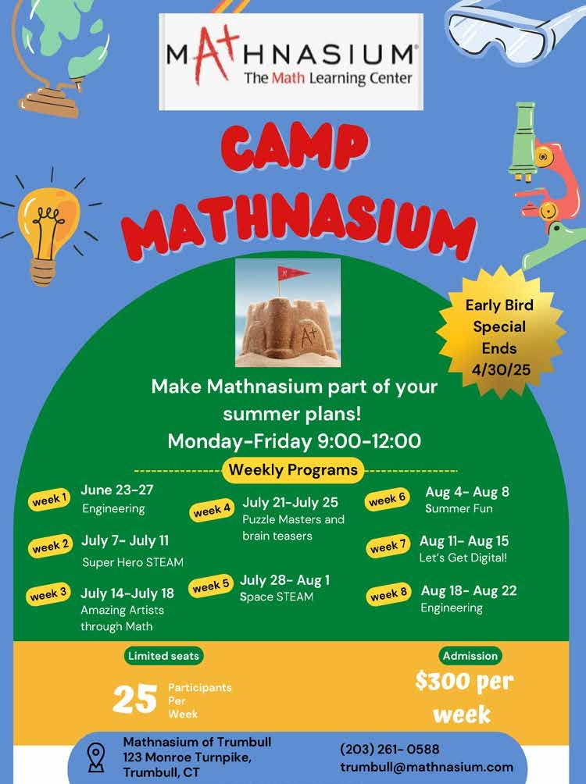

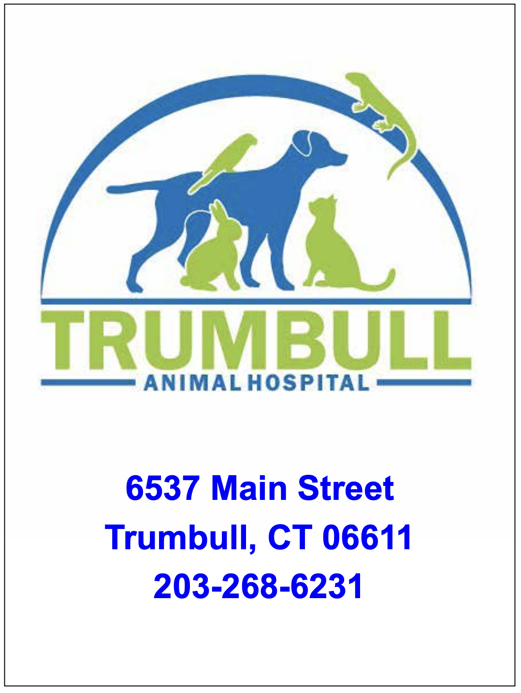





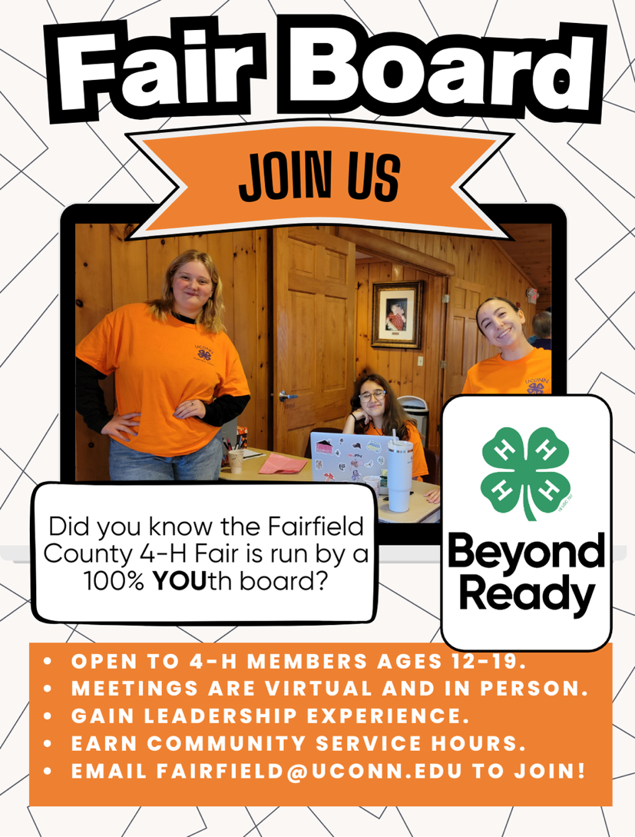



Fairfield Dairy Queen is proud to support the Fairfield County 4-H!
Delicious treats, take home novelties and custom cakes ready when you want them!
 

Dairy Queen 1902 Post Road Fairfield, CT 06824
Raising awareness and funds on behalf of the American Cancer Society. Join us to honor all of those who we’ve lost to cancer and those who are still fighting their battle.
Please consider joining our team!!
You can find us on Facebook: hopeonmainstreet
Hopeonmainstreet@gmail.com




DOG TRAINING - COMMUNITY SERVICE
-CANINE SCIENCE - FIELD TRIPS
- 4-H DOG SHOWS - PUBLIC SPEAKING
- RECORD KEEPING
Meetings are held on the 3rd Friday of each month at 6:30 pm. For boys and girls age 7-18 and their dogs.
Leader - Alison Rogers
For information - ali.rogers44@gmail.com Facebook - Dogs Rule 4-H Club


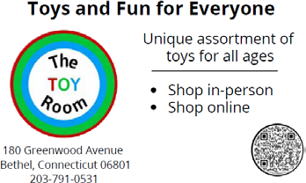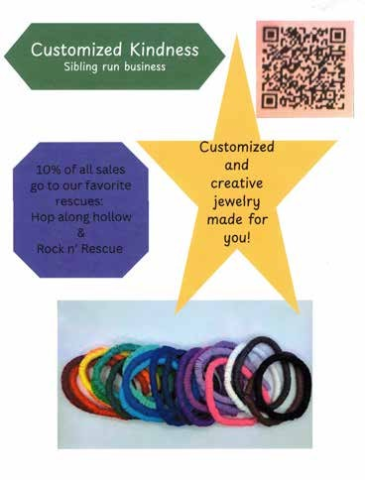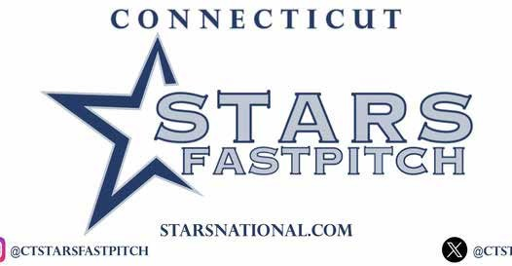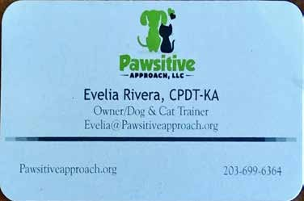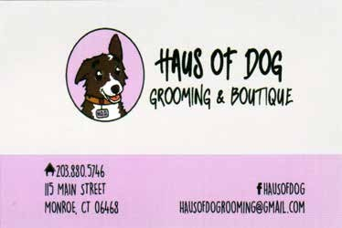

|  |  |  |
| --- | --- | --- |
| Business card for Freed Chiropractic Centre, featuring contact details for Dr. William L. Freed in Trumbull, Connecticut. | Text-based advertisement for Hemlock Hardware, promoting grill sales, same-day delivery, and contact information. | |
| Business card for M & M Heating & Cooling, featuring contact details, services offered, and owner Nick DiPronio's information. | Business card for Dr. Sharon Weicman at Main Street Family Chiropractic Center, featuring contact details and a chiropractic caduceus symbol. | |
| MEATS BY MACK BBQ Let me do the grillin, so you can do the chillin! | Trumbull Pizza Company advertisement featuring contact numbers, delivery info, address, and a pizza illustration. Established in 2016. | Photo of man.  Business card for Michael W. Antonini, Medicare Insurance Broker, featuring contact info and credentials in Trumbull, CT. |
| Logo of Marianna's Pantry featuring a jar graphic, location at 6528 Main St, Trumbull, CT, and contact number 2038809633. |



**This year’s Fairfield County 4-H Dog Show is generously sponsored by**

**Pleasant Paws Pet**

**Center**

Newtown, CT

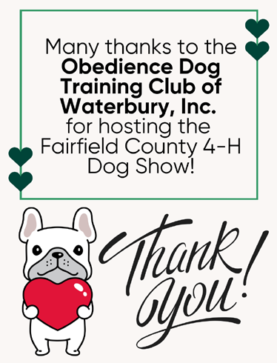

The University of Connecticut complies with all applicable federal and state laws regarding non-discrimination, equal opportunity and affirmative action, including the provision of rea- sonable accommodations for persons with disabilities. UConn does not discriminate on the basis of race, color, ethnicity, religious creed, age, sex, marital status, national origin, an- cestry, sexual orientation, genetic information, physical or mental disability, veteran status, prior conviction of a crime, workplace hazards to reproductive systems, gender identity or expression, or political beliefs in its programs and activities. Employees, students, visitors, and applicants with disabilities may request reasonable accommodations to address limita- tions resulting from a disability.

Contact: Office of Institutional Equity; 860-486-2943; [equity@uconn.edu;](mailto:equity@uconn.edu) [https://www.equity.uconn.edu.](http://www.equity.uconn.edu/)

