UConn 4-H Explorers at the Fair
Explorers are able to participate in Fair activities, although it is important to note they are not judged or evaluated. These are activities for Explorers at the county 4-H Fairs. Each Fair will follow these activities; other activities are not acceptable. Contact your county staff person, who can help you connect with a club to partner up with for these activities.

Activity: WHAT'S IN THE BAG? (3-5 minutes) *
Grade Level: K-2
Materials: Feed sack; various feeding dishes, water bottles, grooming tool; samples of various feed in zip-lock baggies (4-H Cloverbud Curriculum Series I - Pets Curriculum Piece) A volunteer can discreetly collect samples of feed from 4-H’ers around the fairground prior to do this activity.
Instructions to Leader: Do the activity described in Series I. Ask each Explorer to pull item out of feed sack and identify what it is and what animal it is for. If members are unsure, ask the group "Who can help? Who knows what this is?"
Application: Ask members to think of how many items can be used by more than one "Explorer Animal Friend." Ask if they know of other feed or grooming items which were not in the bag. Ask why feeding animals regularly is important; how to tell if the animal is hungry; whether the animal can feed itself; and why grooming the animal is important. The attached activity sheet may be used to supplement this activity.
Activity: HELPING OUR ANIMAL FRIENDS (5-10 minutes) *
Grade Level: K-2
Instructions to Leader: Explorers and an older member serving as mentor will work together at designated feeding time. Older members show Explorer how animal is fed and watered. Safety considerations around all animals, especially larger ones, are paramount. Larger animals should be kept in pens or stalls, and an experienced older member or adult should accompany Cloverbud members into stall and always stand in a protective position.
Application: At a designated time, all Explorers taking part in exercise meet with their Leader. The club takes a "guided tour" of the barn area, with each member taking turns introducing his or her "Animal Friend" to the group. Explorer gives the name of animal, what kind it is and tells what he or she likes best about the animal.

Activity: BEING A BARN HELPER (10-15minutes) *
Grade Level: K-2
Materials: brooms, rakes, dustpans, trash bags, etc.
Instructions to Leader: Older members and Explorers work as partners to help clean areas. Older members demonstrate and explain, then invite Explorers to take over. Explorers should be limited to duties which do NOT involve pitchforks, hoes, wheelbarrows, heavy lifting etc. Older members and volunteers should be prepared to "finish up" if major mistakes are made but should overlook minor oversights.
Application: Leader should ask Explorers: "Why do some things need to be done over and over again?" "How did you feel when you were helping?" "Were some things harder or easier for you?" "Why is it important to keep the places where animals are living clean?"

Activity EXPLORERS FRIEND SEARCH (20 to 30 minutes on Fairgrounds) *
Grade Level: K-2
Materials: "Find a Friend" sheet.
Instructions to Leader: Each Explorer will be encouraged to look for "Silver Friends" (old friends) and "Gold Friends" (new ones) and ask them to sign their list. Parents or older siblings would be asked to help encourage members to do this. Before an Explorer leaves the Fairgrounds, he or she can present the sheet to an identified volunteer and receive a special Fair activity/participation ribbon. If a number of Explorers are on the grounds at the Awards or Closing Ceremony, this could be included, at which time all members could sing, "Make New Friends and Keep the Old."
Application: Explorer members meet at a specified time. Leaders should ask how it felt to see old friends and to make new ones. Ask them to share "opening lines" they used to approach new friends.

Activity: EXPLORERS IN THE EXHIBIT HALL: An opportunity for Explorers to enter items they have made, collected, or grown.
- Fairs offer a class called “Explorers” which covers the range of exhibits offered to older 4-Hers.
- Use the UConn 4-H Explorers Comment Card.
- Entries receive a participation or special Explorers ribbon.

Activity: EXPLORERS FAIR WORKSHOP: An opportunity for Explorers to experience handling an animal in a show ring.
- Note: NO Explorer should have a project animal. Animals are borrowed from older 4-H’ers to use in this workshop.
- Older 4-H’ers and/or a parent may accompany the Explorer.
  - calves (spring calves born 3/1-5/3 only)
  - goats and sheep (small breed or kids/lambs)
  - other animals (rabbit, chicken, pet)
- Each Explorer will share with an adult what they know and/or are learning about the animal they have borrowed.
- Workshop participants receive a participation or special Explorers ribbon.

*Special thanks to ohio4h.org Cloverbud Farms at the Fair by Gregory P. Siek, Cuyahoga County, OSU Extension
The University of Connecticut complies with all applicable federal and state laws regarding non-discrimination, equal opportunity and affirmative action, including the provision of reasonable accommodations for persons with disabilities. Extension program participants with disabilities may request reasonable accommodations to address limitations resulting from a disability. For more information, please contact the UConn Extension Civil Rights Liaison at extensioncivilrights@uconn.edu.
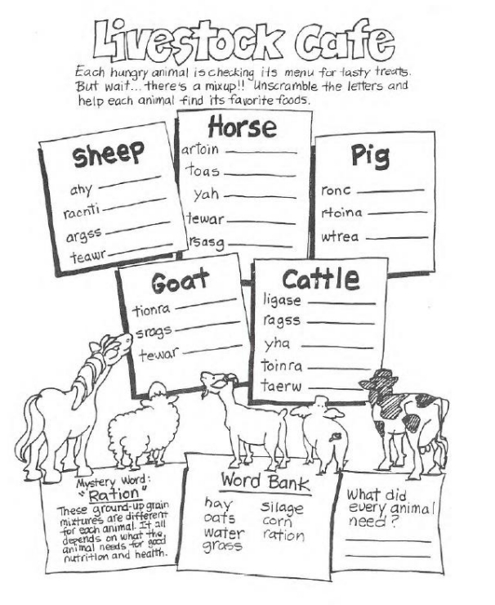Explorers Find a friend
Find old friends (Silver) and make new friends (Gold) at the 4-H Fair. Have them write their name in the box. Give this paper to your Leader for a special prize!
Silver Friends | Gold Friends

