# Becoming a Volunteer of Record Checklist

UConn Extension 4-H Volunteer Trainings are conducted at county, state, and regional locations. 4-H volunteers receive on-line and face-to face trainings on UConn 4-H and being an effective volunteer for positive youth development. All 4-H volunteers who will be taking custodial care of 4-H youth participants such as supervising, chaperoning, or otherwise overseeing minors, must complete a UConn Background Check every four years.

## Getting Started Check List

* Contact the local 4-H Staff in your county office to discuss your interests and time commitments.
* Enroll in Z-Suite/CT (UConn 4-H’s online registration system) and complete the UConn Minor Protection Training through Clover Academy in Z-Suite (See page 3).
* Upon completion of the online 4-H Volunteer Application Form in ZSuite, references will be contacted, and a background check will be initiated.
* Complete the electronic UConn Criminal Background Check (CBC) emailed to you by the UConn Criminal Background Check Coordinator (necessary for anyone supervising youth (custodial care) – see page 2 for details.
* Once step 4 has been completed, a face-to-face Orientation about 4-H and being an effective volunteer will be conducted.
* Once all the steps have been completed, you will receive a confirmation letter stating that you are a Volunteer of Record with UConn 4-H

**You are not a registered 4-H Volunteer of Record with UConn 4-H and are not cleared to meet with youth on your own as part of 4-H until you have received your confirmation letter.**

The University of Connecticut complies with all applicable federal and state laws regarding non-discrimination, equal opportunity and affirmative action, including the provision of reasonable accommodations for persons with disabilities. Extension program participants with disabilities may request reasonable accommodations to address limitations resulting from a disability. For more information, please contact the UConn Extension Civil Rights Liaison at [extensioncivilrights@uconn.edu](mailto:extensioncivilrights@uconn.edu).

# 4-H Volunteer Application Form

The 4-H volunteers work with other adults, children, or groups in a variety of ways. Volunteer opportunities include club leader, project leader, assistant leader, advisory committee member, fair association director/advisor/mentor, camp board member, program committee member and judge/evaluator for a 4-H event or contest. During enrollment in the ZSuite online enrollment system, new volunteers will be prompted to complete a volunteer application form. Note: Once the 4-H volunteer enrollment is received by the 4-H Office, references will be contacted.

# UConn Background Check

All 4-H volunteers who will be taking custodial care of 4-H youth participants such as supervising, chaperoning, or otherwise overseeing minors, must complete a UConn Background Check every four years. This process is completed online. 4-H Volunteers needing background checks will submit their full name, working email and personal cell phone number to the 4-H staff member completing the screening process. They in turn will receive an electronic request from the UConn Background Check Coordinator with information about the online background check process. This email will be from UConnMPP@screening.services.

Human Resources will request directly from the volunteer any additional documents or forms that are needed.

If someone is unable to complete the online process, they should contact the State 4-H Office at [4-H@uconn.edu](mailto:4-H@uconn.edu) to request further assistance.

A screenshot of a computer Screen


Go to <https://4h.zsuite.org/> and select Sign-Up and Register New Household

A screenshot of a computer Screen


Enter Household Information

A screenshot of a computer Screen


Go to Dashboard and Select “+ Household Member”

A screenshot of a computer Screen


Enter your Personal Information

A screenshot of a computer Screen


Complete the three waivers attached: Annual Connecticut 4-H Volunteer Agreement Form, 4-H Volunteer Application Form, and UConn 4-H Volunteer Code of Conduct. Once completed, your application with show “Pending Approval”

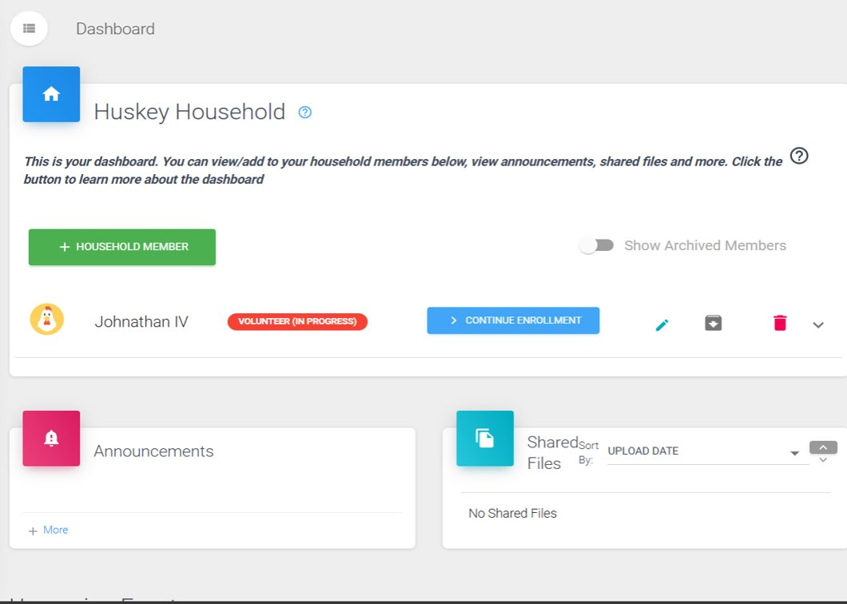

A screenshot of a computer Screen


Once the forms are completed select “Clover Academy” tab and enroll in the Minor Protection Training for the current year