Connecticut 4-H Horse Judging Guide
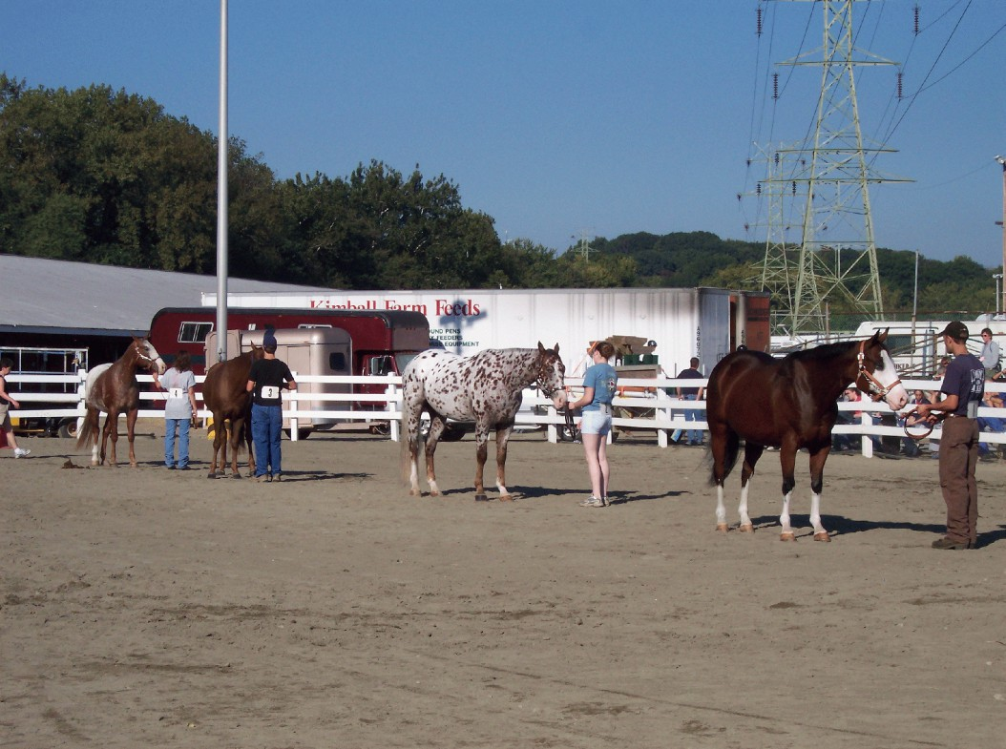

By Margaret I. Rausch

Connecticut 4-H Horse Judging Guide
Margaret I. Rausch

Why Horse Judging?

Horse judging is a useful skill for many people, not just those in the horse industry. Horse judging will help a 4-H’er recognize desirable and undesirable qualities in horses, it will also help the 4-H’er make logical decisions and defend those
decisions. These are important skills that are useful throughout life.
This guide is designed to help the reader learn how to evaluate horses and how to apply that knowledge. It is not intended to be the answer for everything, and it contains only the basics. To progress further in judging for specific breeds, it is best to contact that breed association and ask for their judging standards.
One of the most important things to remember is that judging should be fun and enjoyable. For those just starting, do not become discouraged if you do not get everything right the first time. It takes a long time to become good at judging horses. Any judge will tell you that as
breed association rules are always changing, they are constantly learning. Just do your best, have fun, and enjoy yourself.
This guide includes the basics of evaluating conformation, evaluating performance classes and will finally discuss giving oral reasons.
Conformation refers to any class where the horse is shown in hand. These classes are judged on how the horse is put together structurally. Performance refers to any class where the horse is under saddle or harness. These classes are judged on how the horse moves (way of going), manners, responsiveness to the rider, or how well they complete a pattern.
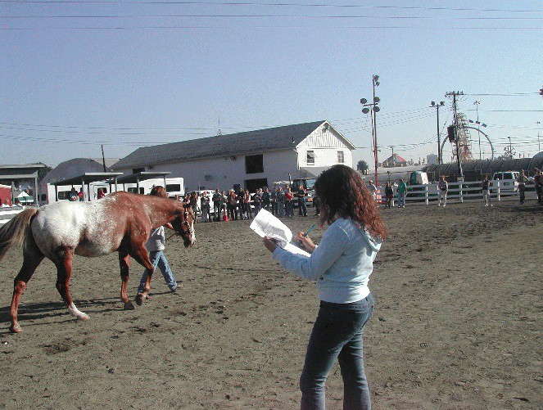
Before beginning to judge horses, it is important to know the names and locations of the parts of the horse (figure 1). This is particularly important when giving a set of oral reasons.

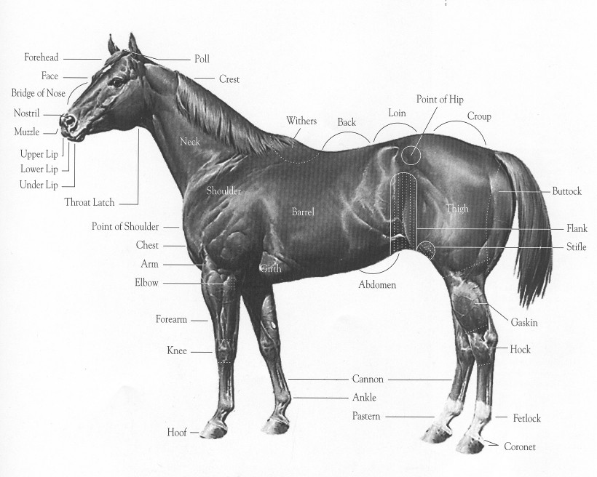
Parts of the Horse
Figure 1

Evaluating Conformation

The major points to consider are:
- Balance, the “thirds” of the horse, the proportions
- Heart girth
- Structural correctness, particularly in the legs
•Muscling: quantity, quality, and the type of horse
- Quality/overall refinement
- Breed and sex characteristics (masculinity and femininity)
- Movement/travel

There are three basic steps involved when evaluating a horse: overall appearance (is the horse pretty), tear them apart (are they balanced, are they structurally correct, etc), and put them back together for an overall evaluation. The horse that exemplifies the best characteristics in all of these areas will be the top horse.
When judging a class get a first impression by walking the line of horses from a distance. This will give create an overall impression of type and how the class will sort itself out. This first impression will help initially sort the horses into pairs and will help to identify if there is an obvious top or bottom horse.
Remember the most important part of any class: keep “types” together, like with like.

Balance
There are three main parts of the horse that should be of equal length; the shoulder, midpiece, hindquarter. Ideally the shoulder, back, hip, head, and neck should all be the same length. A horse should not be faulted for having a shorter (or longer) head as much as a horse with a shorter (or longer) back or hip. The most important lengths that should be in balance are the shoulder, midpiece, and hindquarter (the neck is also sometimes included in this). Refer to figure 2 for a visual representation of this.
The depth of the heart girth should be equal to the length of the legs; the horse should also be the same height at the withers and the croup. It is important to note that in young horses the hindquarters may grow at a quicker rate than the withers. As a result, young horses that “run downhill” should not be faulted as severely as a mature horse would be. In addition, the width of the horse’s chest should generally be the same as the width of the hindquarters.

BAIANCE
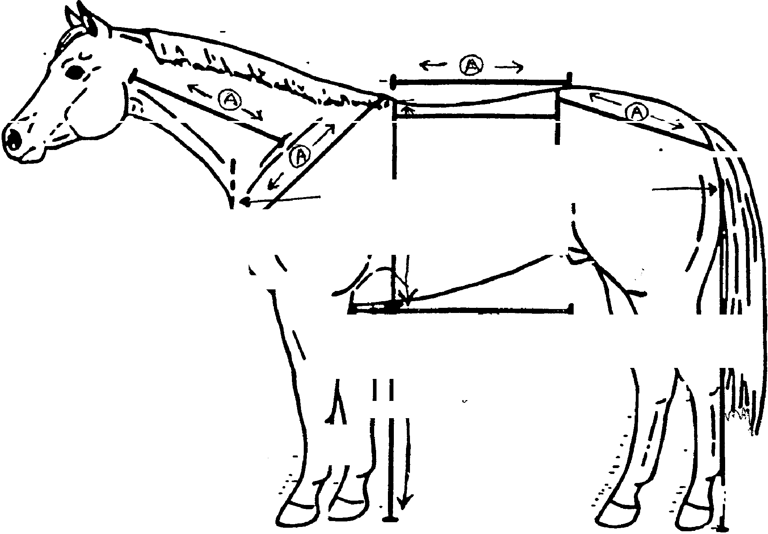
\/3_. ,--113
T
(
►\
\
I
-
1/3
�
I -
' '
I
v
"
r�
®
I
I
I
I
I

To evaluate balance, stand 25 to 35 feet from the center of the horse's side.

Horizontal Balance (front to rear) is evaluated by drawing imaginary lines at the point of the shoulder, heartgirth and point of the hip. Each section should divide into three equal parts.

A Vertically Balanced horse should be the same height at the wither as at the hip and have the same depth of heartgirth as from the bottom of heartgirth to the ground (lines labeled "B")

The neck, shoulder, topline and hip should also be of similar length (lines labeled "A")
A well balanced horse should have a topline {back and loin) that is shorter than it's underline (from heartgirth to flank) - compare line labeled "C" to line labeled "A" above it.
Figure 2

Structure
Structural evaluation includes the neck, shoulder, withers, upper leg, width of chest, lower leg, back and loins; the croup, and the hip.
Shoulder: The ideal length matches the rest of the horse, an angle which is appropriate for the breed (for most horses this is approximately 45 degrees), and one that ties in correctly to the neck. How the neck ties in with the shoulder will vary somewhat with the breed. For most breeds the ideal neck and shoulder flow smoothly together; there is no apparent “break” in the top line.
Chest: A very narrow chest is undesirable because it affects a horse’s way of going. However some breeds do promote a wider chest than others. The legs should come straight down from the chest with a reasonable amount of space between them. The legs should not be spaced too far apart or too close together.
Upper Leg: Should be straight with the knee set on square, not off to the side.
Lower Leg: Should tie in to the center of the knee and come straight down. The pasterns should have adequate length in relation to the rest of the horse and have a slope that approximates the slope of the shoulder. If the leg is not straight it will not absorb concussion from movement as well and this could lead to various degrees of unsoundness. A high splint is a sign of deviant structure. A bench knee is when the cannon bone
is offset. Being over in the knee (buck-kneed) is usually considered to be not as severe a fault as behind in the knee (calf kneed).
Withers: Should tie in nicely with the neck and show a smooth line
Back and Loin: Ideally the back should be short with a long underline (the line of the stomach). The shorter the back the stronger.
Croup: Should be long with slope according to the breed.
Hip: Should be the same length as the shoulder and show a mirror image of the slope of the shoulder.
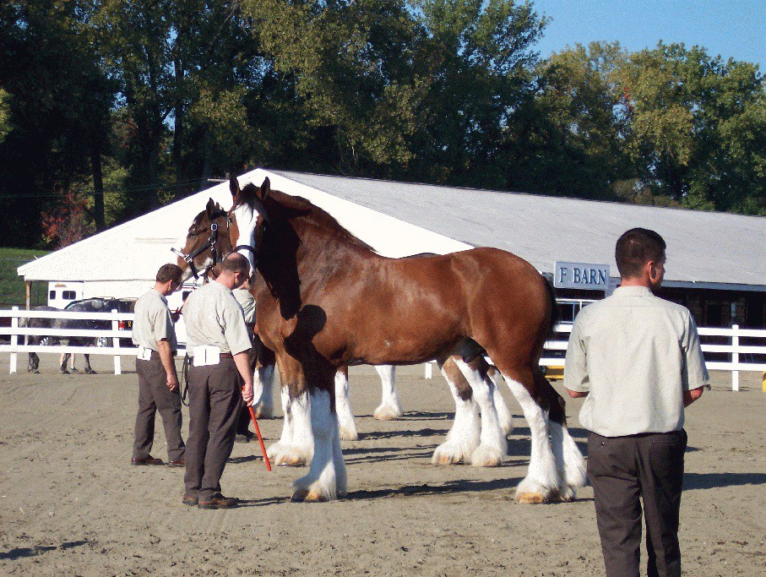
Hind legs: A line dropped from the point of the buttocks should carry straight down along the back of the cannon bone. Generally the hind cannons are longer than the front cannons. The hind pasterns also tend to be steeper and the hind feet more pointed. Common defects include sickle hocked and post legged. Other common faults include: cow-hocked, bowlegged, splay footed, and pigeon toed.

Ideal | Toes out | Bos.v-legged | Stands close | Toes | out | Knock-kneed | Pigeon-toed
- '\ |  |  | - ·.:; ·,

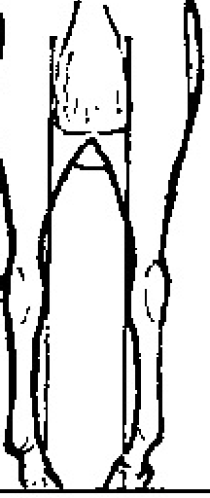

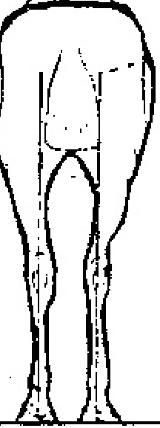
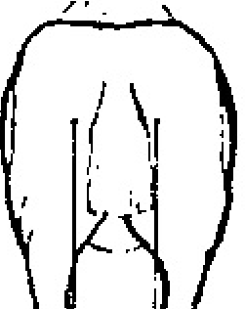

Ideal
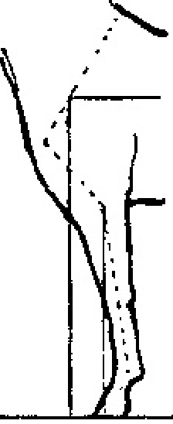

I
Stands wide Bow-legged
Stands close
Co\v-hocked

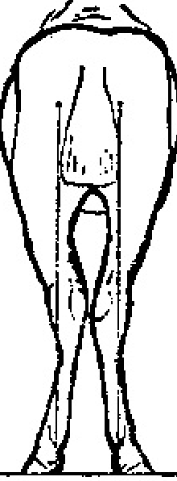
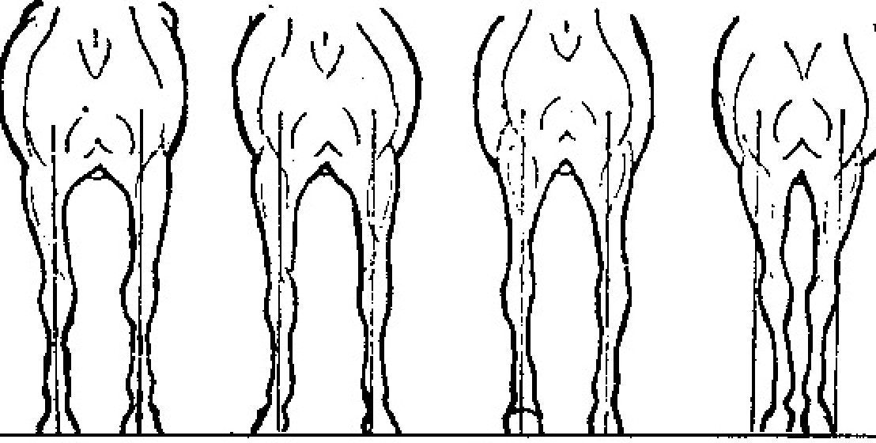

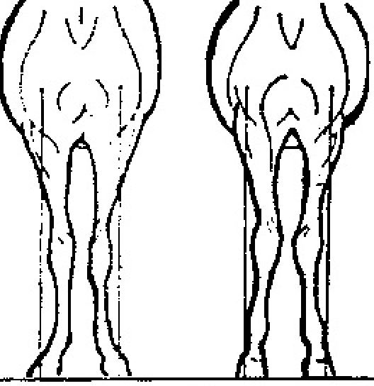

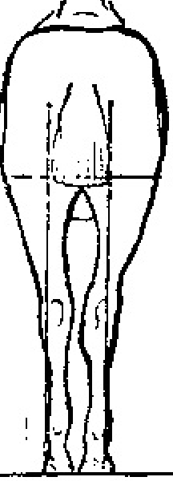

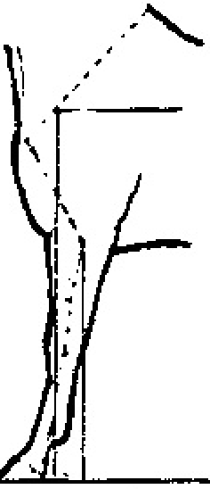

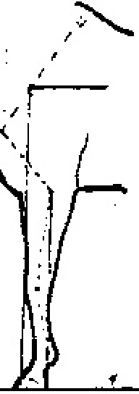

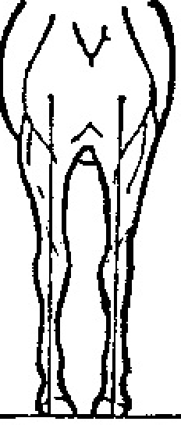

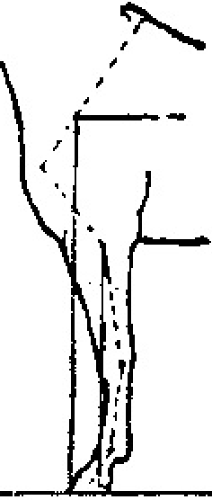

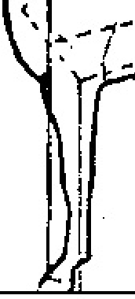

Ideal Camped under Camped out Knee-sprung Calf-kneed
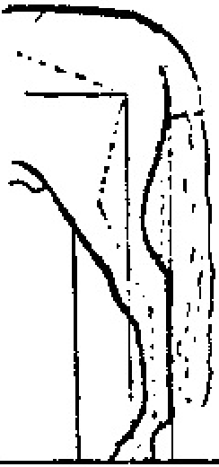

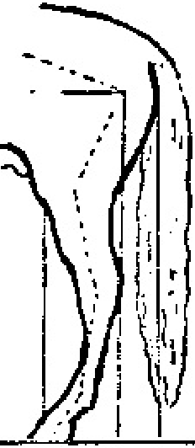

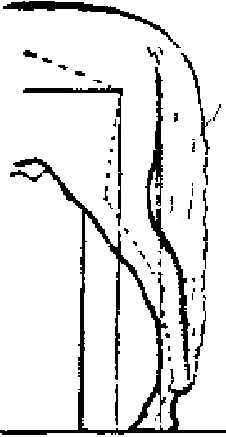

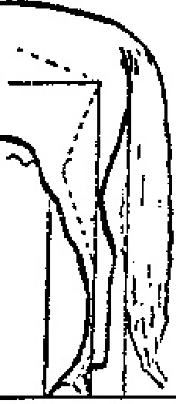

Ideal Stands under c�mped out Hind leg too straight

Quality
Quality is evaluated in the head, throat latch, neck, hair coat, cleanness of bone, and being free of blemishes.
Head: From the front the head should look like a triangle. The length from the ear to the eye should be the same as the eye to the muzzle. The more desirable characteristic is to have a wide space between the eyes. The muzzle should be small but still in proportion to the horse as a whole. The nostrils should be fairly large to allow for adequate air intake. A smooth straight nose is desirable that is flat over the jaw. The eye should be expressive, large, and clear. A prominent cheek bone is considered ideal. For many breeds, the ears should be small and fox like. Ears should also show expression and be forward and erect when the horse is attentive. Some common faults of the head include: roman nose, roughness of the lower jaw, floppy ears, a small eye, narrow between the eyes, and small cheek bones.
Throat latch: A small, clean (neat in appearance) throat latch that will allow the horse to flex easily at the poll is desirable.
Neck: Should be clean and on the slimmer side. The neck should tie in high to the shoulder and show a smooth line. Some faults include: too thick, being overly cresty, ewe neck, and tying in low to the shoulder.
Legs: The bone should be smooth, flat
(often referred to as being clean of bone), and free of blemishes.
Overall the horse should be in good physical condition with good muscle tone and a nice hair coat.

Muscling
Muscling is evaluated by looking at the length, size, and expression of the muscle. Primary muscle areas to focus on are the chest, pectorals, shoulder, forearm, back, loin, stifle, and gaskin. It is important to note that the quantity of muscling will vary with the breed.
The major muscle groups should be well defined by “lines” that show where one muscle starts and another stops. In the chest the muscling should be large, prominent, and bulging. The pectoral muscles should show a well developed inverted “V”. Shoulder muscles should be large and round. The forearm muscles should be large, heavy, and well defined. They should tie in deep and low on the leg. Back and loin muscles should be of adequate width so as to support the horse and provide impulsion from the hindquarters. The stifle muscle should tie in deep with the gaskin and be wider than the hip to allow the leg to move. In the gaskin both the outer and inner muscles should be well developed and bulging; there should be the same quantity of muscling both inside and out.
They should tie in low to the hock and be relatively

equally developed.

Breed Type
Quality of the head and neck, volume of muscling, size of the body, and overall substance will vary with each breed. The horse should display the characteristics of its breed (having good breed type). Mares should look like mares and not be as masculine as a gelding or stallion. Mares should
be more refined through the head and neck and will not have the quantity of muscling that a stallion or gelding will exhibit. Stallions will have a greater quantity of muscling and often have well developed necks and foreheads. It is best to review the standards for each breed to become familiar with the breed characteristics.

Way of Going
It is desirable to see a good length of stride with a fair amount of freedom in the way the horse moves. The length of the stride should be equal when looking at the fore and hind legs. The feet should travel in a straight line and be placed equally on the ground.

It is important to remember that each breed will emphasize different conformation characteristics. When looking at specific breeds be familiar with the desired breed characteristics.

Performance Classes
With all classes, check to see what the rules are for individual breed associations. The rules presented here are based on AQHA rules. Rules may vary according to association.

Western Pleasure
There are five basic factors to consider when judging a western pleasure class:
•Functional correctness
- Attitude
- Quality of movement
- Head carriage and head set
- Manners

Functional correctness: Consider the gait, walk, jog, and lope, and the way the horse moves in the two directions of the ring (needs to be consistent). The horse should travel straight and look straight through the bridle. Transitions should be smooth, prompt, and the horse should back in a straight line willingly. The horse should pick up the correct leads as soon as the rider asks for them and all transitions should be executed promptly.
Attitude: The horse should move in a consistent and steady manner, and not be excessively slow or fast. The horse should appear to be relaxed, calm, and obedient to the rider. The rider should have good control over the horse while maintaining a light or loose contact on the rein.

Quality of movement: There should be a reasonable length of stride that is symmetrical in both the front and hind legs. There should also be symmetry of stride when comparing the distance each leg travels. The horse should be collected, thus enabling the horse to obtain its drive and power from the hindquarters. There should be a reasonable length of reach of the hind leg in relation to the underbody, i.e. the horse should reach under itself. There should be a distinct cadence to each of the gaits giving the rider a smooth fluid ride. The walk should have four beats, the jog a distinct two (no matter what the speed), and a rhythmic lope with three beats.
Head carriage and head set: Head set should be naturally flexed at the poll with an angle between the vertical and 30 degrees (this is referred to as the head set). The head carriage (position of the neck) should appear natural and be very close to the horizontal showing little movement. It is important to note here that certain breeds have specific restrictions on the head carriage and may disqualify a horse from a class if it is incorrect.
Manners: The horse should be quiet with its mouth, ears, and tail. The horse should have a pleasant appearing attitude, one that looks like it is a pleasure to ride. The horse should not overly swish its tail, this is especially seen on lope transitions.
Most of these points are important in any under saddle class. The head carriage, head set, and speed of the gaits are the main variable factors between the different classes. In the remaining classes listed here, only the differences will be noted for each class.

Hunters and English Pleasure
The horse should show a greater length of stride than the western pleasure horse, but still remain symmetrical. Knee and hock action should be low to the ground, with a springy quality to the gait. In essence you want the horse to almost float over the ground. Most important in this class is suitability to purpose, i.e., the horse looks like a hunter. There will be more rein contact in a Hunter class then in an English Pleasure class. Head carriage will tend to be slightly higher than in a Western Pleasure class, though much of this is breed specific.

Pleasure Driving
The Pleasure Driving horse is basically an English pleasure horse. The gaits are different, typically including the walk, the slow trot, the working trot, and the extended trot.

Hunter Hack
In this class there are typically two fences

that each horse must jump and then all horses will do rail work. The best way to place this class is to use a point system. Give each jump a score from one to ten and then add up the two scores. The higher the score the better so the horse with the highest score wins. Typically rail work is used to break ties. The horse should jump the fence in the middle and have even take off and landing distances. The knees should be tucked up well to the chest and should be of equal height. Refusals should be penalized and after the third refusal the horse is disqualified. If the horse knocks a rail down or hits it they should also be penalized. Most important here is to be consistent in scoring of the jumps.

Equitation
This class is based on the rider’s ability as determined by performance in a pattern. Score the pattern and place the class based on these scores. Typically it is easiest to base this score on twenty, however use whatever system is most comfortable. The rail work done should be used to break ties.

Western Riding
This is a western pleasure class that does flying changes of lead. There are several AQHA patterns for the class. In most contests, any pattern will be provided to each contestant; however it is recommended to be familiar with them.
The most common pattern used is AQHA pattern one. In this pattern there are a total of eight changes of lead, they are divided into four line changes and four crossing changes. Each change of lead should be in the center of the two cones.
Changes should be flat and even with no hesitation. Most important is the fact that the change should occur simultaneously in the fore and hind legs.
When jogging and loping over the log the stride and gait of the horse should not change. The horse should go over the center of the log and be very calm. The horse should not jump over the log.
In this class using a score sheet is the most helpful way to place the class. Each score is based on 70 points, maneuver points and penalty points are added or subtracted to the base score of 70 to obtain the final score. Divide the pattern into different maneuvers and score each maneuver on a scale of -1 ½ to +1 ½. On this scale a score of -1 ½ is extremely poor, -1 is very poor, -1/2 is poor, 0 is average, +1/2 is good, +1 is very good, and +1 ½ is excellent. For riding pattern one there are a total of 14 maneuvers. These maneuvers are: the walk; transition to the jog, jogging over the log; transition to the lope; four line changes (each one is a separate maneuver); two crossing changes; loping over the log; two crossing changes; lope, stop, and back for ten feet; and overall pattern. There are also penalty points, these are listed separately. The highest score wins the class.

are often changed. Make sure you familiarize yourself with the system that will be used.
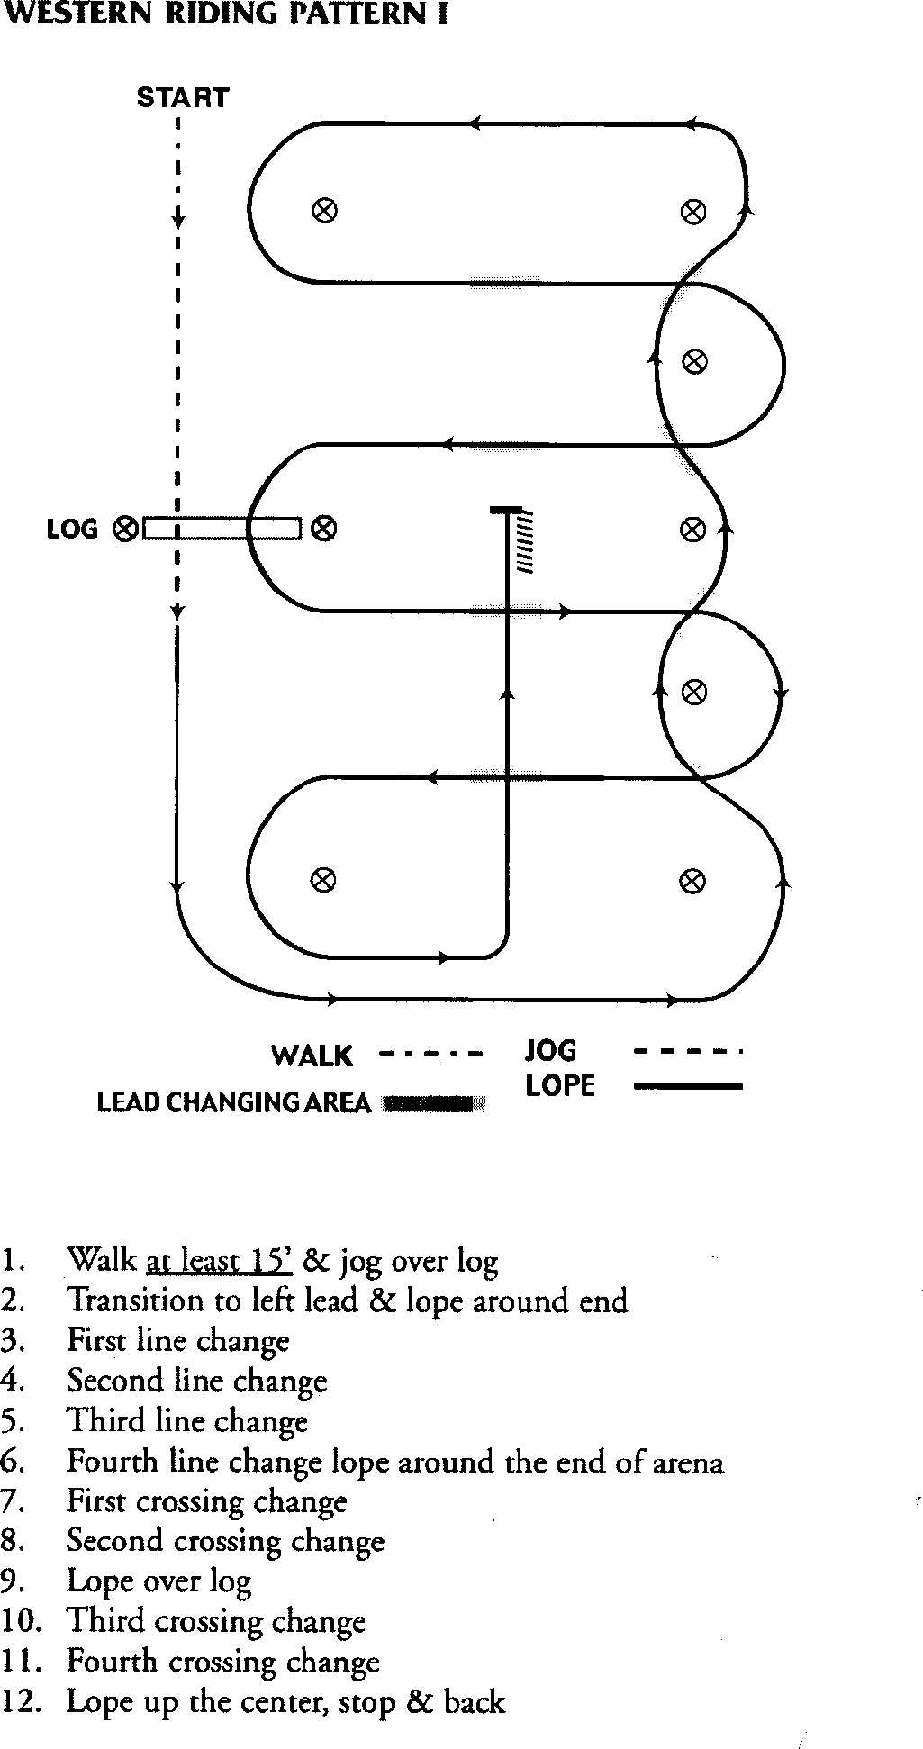

Reining
As with Western Riding, most contests will provide the pattern. It is recommended to be familiar with the patterns. The rider must always be in control of the horse, who must have blind faith in their rider in this class. Blind faith refers to the horse performing the pattern without hesitation, anticipation, or apprehension. There should be little contact on the mouth during this class. The horse should be very responsive and willing to the
rider. The horse should challenge the pattern; when the circles are to be large and fast the horse should almost be in a full gallop, when doing small slow circles the horse should be in a pleasure lope.
In the circles the horse should be bent in the direction of the circle, not to the outside. There should be a distinct size and speed variation in the circles.

Penalty Points for Western Riding

There are varying degrees of penalty points for this class, some will even disqualify a horse and rider. Refer to the specifics rules for each contest to find out what these points are. Different associations have different penalty points and they
In the spins the pivot foot should remain planted, there should be a flat body line, the horse should be supple, with the outside foreleg crossing over. Spins should also be fairly quick.
The sliding stops should be smooth with a lot of distance. The horse should not bounce through the stop. The horse should also not

anticipate the stop. The rollbacks should be smooth and fluid with little hesitation shown by the horse.

As with Western Riding, this class is placed based on a scoring system. The base score is 70, points are added or subtracted for each maneuver in the pattern and penalty points are also possible. A chart system should be used when judging this class. Each maneuver is scored on a scale of -1 ½ to +1 ½, the scale exactly the same one that is used in Western Riding. Each pattern is different so the maneuvers will vary by the pattern.

Penalty Points for Reining

As with Western Riding; there are varying degrees of penalty points for this class, some will even disqualify a horse and rider. Refer to the specifics rules for each contest to find out what these points are. Different associations have different penalty points and they are often changed. Make sure you familiarize yourself with the system that will be used.

Giving Oral Reasons
Reasons is often the most intimidating part of a horse judging contest for many people. If properly prepared, it should be looked upon as a learning experience that is enjoyable. Oral reasons will enhance a contestants ability to speak in public, develop self confidence, and the ability to think on their feet. In giving a set of reasons the contestant will be explaining why they placed a particular class of horses the way they did. It is important to keep in mind that the way a class is placed should not affect the score given for a set of reasons. Oral reasons are scored based on accuracy, relevancy, organization, terminology, and presentation. As with the class score, a perfect score is 50. A score of 46-50 is for good to excellent; 41-45 above average to good; 36-40 average; 31-35 below average; a reasonable well prepared and completed set of reasons should not score below a 25. There is a basic format that is followed for giving a set of reasons, regardless of type of class. The most important aspects to keep in mind are to be well organized in the way the class is discussed , use comparative terminology, talk about the “big” items in each class (do not focus too much on the little details), and speak slowly and clearly. It is also important that the past tense be used when giving a set of reasons. Incorporate voice inflection to emphasize important points in the reasons.
Contestants should appear confident as they speak,
but not cocky.
It may be easier to write out reasons in full sentences, or it may be easier to write little notes. It is important to keep in mind that what may work for one person may not work for another. Use notes as a reference when preparing reasons.
Another important thing to keep in mind, is that reasons do not have to be said exactly how they have been written. Mention all keys points during a set of reasons, it can be slightly different in exact wording each time. Reasons are not a memorization skill, they are learning to speak in front of someone comfortably.
Many people find that organizing their notebook in a specific way as they take notes for a class helps them when it comes time to work on a set of reasons. Here is just one example of a way to set up a notebook.

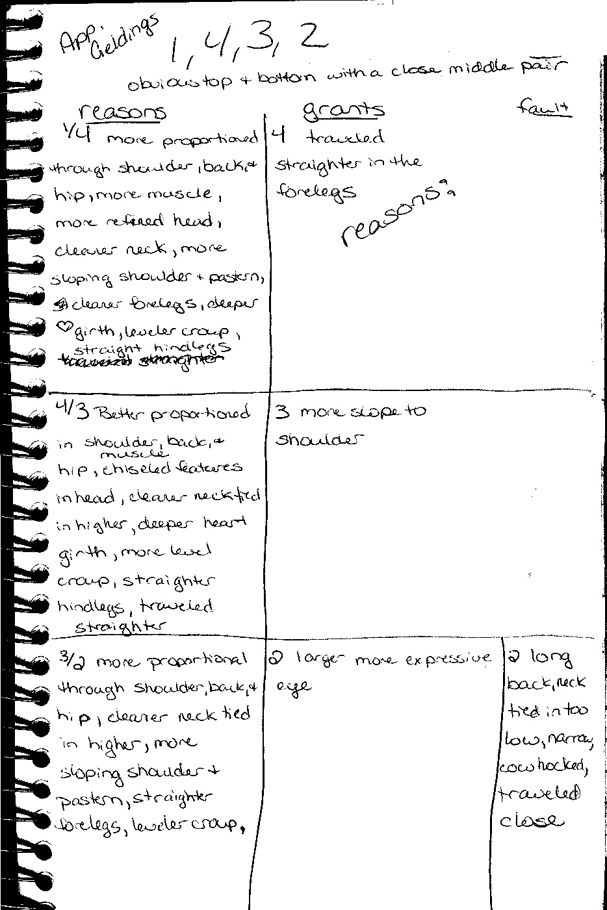

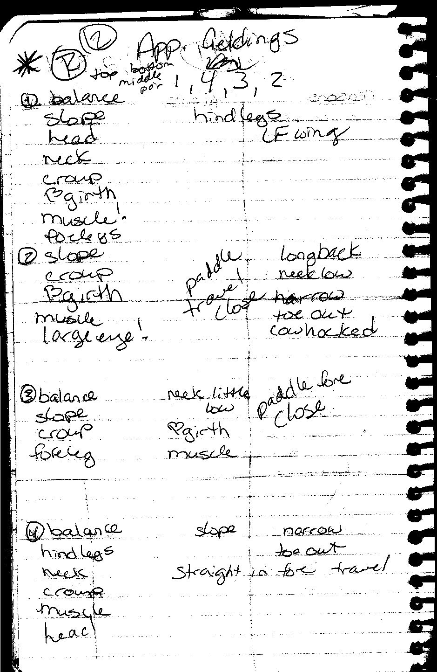

Outline for Reasons Opening statement: A broad description of the class that gives the reasons judge the placing.

Comparative:
Top pair: I placed 1 over 2 because....
I grant 2...
Transition: ties grant 2 in with 2 over 3
Middle pair: I placed 2 over 3 because...
I grant 3...

Transition: ties grant 3 in with 3 over 4
Bottom pair: I placed 3 over 4 because...
I grant 4...
I fault 4...

Closing statement: This concludes the reasons and restates the placing.

As reasons are written there is a type of order that should be followed depending on the class. For halter classes start with an overall view and then move from the front to the rear for each horse. Mention the way of going last. For performance classes go by the order in which things happened during the class.
Here is an example of a set of reasons for a halter class.

“Sir, I placed this class of aged geldings 1-
2-3-4, finding in 1 an individual that showed the highest, most favorable combination of balance, muscling, and structural correctness.
In the top pair, I placed 1 over 2, because 1 was longer in the neck, longer and more sloping in the shoulder and broader across the chest, indicative of a greater volume of muscling in the pectoral area. One stood on shorter cannon bones with the cannon dropping straighter down from a flatter knee. Also, 1 was deeper in the heart, shorter and stronger over the back and loin, and longer in the croup. When viewed from the rear, 1 was wider and deeper tying in the stifle, and showed much more separation in both the inside and outside gaskin. Further, 1 also stood straighter through the hocks. I grant that 2 was of higher quality in the face and stood on more sloping pasterns, and therefore in the middle pair, I placed 2 over 3.
Two was cleaner and sharper in the face, broader and more finely chiseled in the chest, longer and more angular in the shoulder and straighter at the toe. Also, 2 had greater circumference in the heart girth and was shorter and stronger in the back and loin. In the hindquarters, 2 was more powerfully muscled throughout, being longer in the hip and more bulging in the stifle. I admit that 3 was leaner in the neck and traveled with more snap and flexion in the knees and hocks, and moving to the bottom

pair I placed 3 over 4.
Three was more proportional throughout, and was shorter in the face, broader across the chest, more powerfully muscled in the forearm and straighter down the front leg, particularly at the knee. Three showed more depth to the heart girth, was much shorter in the back and loin in relation to a longer underline and stood lower on the knees and hocks. Also, 3 stood on a straighter, more correct hindleg and traveled truer and sharper than
4. I realize that 4 was longer in the neck, but I left 4 on the bottom of this class, because 4 was plain in the head, offset in the knee, steep in the shoulder, much too long in the back and poorly balanced throughout.
For these reasons I placed this class of aged geldings 1-2-3-4.”
It is our hope that this guide will be helpful in better understanding the various aspects of horse judging. With this as a reference, you should now know what qualities to look for when judging horses in hand, and under saddle. It will also give you the basis for developing a set of reasons.
Remember the only way to become good at judging horses and giving reasons is to constantly practice and learn from others who are experienced at judging. It is also important that you use the breed associations and the resources they have available for their specific standards. A list of terminology for reasons has been included for your benefit.
Good luck in developing your judging skills, and remember to go out and have fun in the process.

Vary the terminology used throughout the set of reasons as well. A list of both halter and performance terminology has been included. The

General

Terminology

Halter

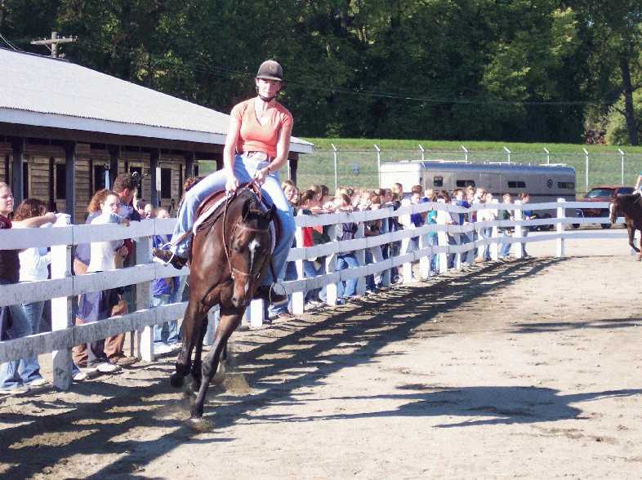
terms used should not only be descriptive in nature, but also comparative.
- More nicely balanced
- Taller
- More athletic appearing
- Larger
- Larger bones
- Cleaner bones
- Higher quality
- More refined
- More feminine

- Heavier muscled
- More structurally correct
- Stood on more substance
- Greater depth of body
- Greater depth and length
- Higher combination of.....

Bone Structure
- Larger, flatter bones
- Straighter column of bones
- Knees and hocks lower to the ground
- Longer boned
- Cleaner boned
- Straighter and more symmetric in the knees

Throat latch
- Smaller
- Cleaner
- Neater
- Thinner
- Trimmer

Neck
- Longer
- Cleaner
- Neater
- Cleaner down the top
- Thinner
- Higher tying into the shoulder
- Tied higher and smoother into the withers

Balance
- Knees and hocks lower to the ground
- More nearly proportional
- More nearly level
- Shorter and stronger in the cannons

Muscling
- Heavier muscled throughout
- Longer muscled
- Deeper tying
- Smoother tying
- More definition

Head
- Higher quality
- More refined
- More chiseled appearance
- Breedier
- Smaller about the muzzle
- Shorter in the face
- Larger eyed
- More prominent jaw
- Smaller fox-like ear
- More feminine
- More tapering muzzle

Withers
- Sharper
- More prominent

Shoulder
- Greater length
- Longer more sloping
- Longer more desirable slope
- More correct
- Deeper through
- More angle

Forearm
- More bulging
- Ties in deeper and smoother to the knee
- Greater circumference
- Lower tying

Front Leg
- Shorter, flatter cannon bones
- Straighter and more symmetric in the knees
- Straighter in the toes
- Straighter down the knees

Feet
- Larger more rounded

Heart Girth and Barrel
- Deeper in the heart
- Greater depth of heart
- Cleaner barrel
- Neater barrel

Back
- Shorter and stronger in the back
- Shorter and stronger in the top line
- Shorter in the back in relation to the underline

Loin
- Stronger over the loin

Chest
•Wider through the floor of the chest
•Deeper in the chest
- More prominent pectoral
- More heavily muscled
- More defined
- More bulging
- Greater separation and delineation
- More powerfully developed

Pasterns
- Stronger
- Longer, more sloping
- Greater length
- More desirable slope
- More correct angle to

Croup
- Longer, more nearly level over the croup

Hip
- Deeper through the hip
- Longer through (or in) the hip
- Wider through the hip
- Greater length through the hip

Gaskin
- Greater circumference
- Larger, more bulging
- More powerful
- More symmetrical inside and out

Stifle
- Wider though the center
- Wider through the stifle
- More defined
- Deeper tying into the gaskin
- Greater width and depth
- Longer
- Thicker
- Greater length of stifle when viewed from the side

Hindleg
- Straighter down the hock when viewed from the side or rear
- Straighter and more symmetric in the hocks
- Straighter in the toes when viewed from the rear.

Tracking
- Straighter
- Truer
- More correct
- Less lateral deviation in the knees and hocks
- Less lateral movement in the knees and hock
- Longer strided
- More snap and flexion

Transition Words
- Furthermore,
- Even so,
•Nevertheless,
- However,
- And,
- Moving to
- Therefore,
- I admit
- I grant
- I realize

Performance Functional Correctness
•More suitability to purpose
•Better fulfilled the requirements of the class
- Maintained gaits without anticipation of cues
- Traveled straighter down the rail
- More efficient in utilizing both leads
- Easier to show
- The back:
  - Honors the bridle
  - Backed with quieter mouth
  - Softer Mouth
  - Straighter, more freely, promptly, voluntarily, backed with less aid and cuing from the rider, backed with less effort (less resistance to the rider).
•Gait transitions:
  - More prompt, efficient
  - More responsive (cues from the rider)
  - Smoother, more fluid
  - Worked with less aid and cuing from the
rider

Quality of Movement
- Walk:
  - Freer
  - Flat footed
  - Consistent
  - Covered more ground
- Trot/Jog:
  - Slower
  - Longer strided
  - More extended
  - Freer moving
  - Softer
  - More collected

  - More distinct
  - More deliberate
  - More cadenced
  - More attractive (prettier)
  - Hindquarter driven up under
  - Engaging hocks
- Canter/Lope:
  - All of the above terms
  - More fluid
  - More flowing
  - Natural, free moving
  - Traveled with feet lower (closer) to the
ground
  - More athletic
  - Straighter

Attitude and Manners:
- More responsive
- More willing
- Calmer
- More relaxed
- Quieter, steadier
- More alert
- Fresher
- Worked on a looser rein
- More consistent
- More solid (seasoned, broke)
- More disciplined
- Quieter in the mouth
- More attentive (expressive)
- Required less obvious cues from the rider
- Responded with lighter, more subtle cues
- Kinder
- Softer in the mouth
- Looser working
- Worked on looser rein throughout the class (or a higher percentage of the class)
- More responsive to pressure
- Worked with less resistance to the rider
- Looked straighter through the bridle
- Head carriage:
  - Steadier head carriage
  - Head carriage more nearly parallel to the
ground
  - Headset more nearly perpendicular to the
ground
  - More flexion at the poll

Mannerisms:
- More pleasant attitude
- Less resistant to rider
•Less objectionable to rider or other horses in class
- Quieter with ears and tail or bit

Reining: Movement and Preciseness
- Moved faster or with more dispatch
- Challenged the pattern more
- Ran faster
- More fluid moving
- Free moving
- Stopped harder
- Slid farther

- Stopped straighter
- Stopped smoother
- Backed more readily
- Backed straighter
- Settled quieter after the stop
- Rated circles more uniformly
- More size and speed variation in circles
- More precise in the circles
- More correct in head and body position in circles
- More precise in lead changes
- More functional in leads
- Flatter more simultaneous lead changes
- More correct in lead changes
- Went straighter into the roll backs
- More snap to the roll backs
- Spun harder
- More precise in the spin
- Turned over the pivot foot more correctly
- Spun lower to the ground
- More exact in spins or pivots

Equitation or Horsemanship
- Presented the most desirable picture of horse and rider working in unison
- More effective rider who showed their horse to its fullest potential
- Executed aids with more discretion
- Maintained a picture of confidence and control
- Sat taller in the saddle, riding with more style and confidence
- Showed a more elegant and correct posture
- Maintained a smoother and more controlled ride throughout the class
- A stronger, more capable and confident rider
- Carried their head up and was more alert, attentive, and confident
- Sat deeper in the saddle with weight more evenly distributed
- Was quieter and deeper seated
- Steadier at the canter or lope, sitting deeper in the saddle
- Was squarer in the shoulders, yet more relaxed in their back
- Maintained the proper vertical line from shoulder to heel at all gaits
- Had kinder, more sympathetic hands and was relaxed in their arms
- Lighter, more effective hands
- Maintained a horizontal line from bit to elbow
- Stronger, more effective leg with more angulation to the heel
- Carried more weight with their heel
- Had a more secure leg that maintained closer contact with the sides of the horse
- Easier and more fluid posting at the trot
- Maintained correct diagonals at the trot and correct leads at the canter
- Maintained a smoother and more controlled ride throughout the class
- Stayed with their horse and sat transitions more smoothly

