Windham County 4-H Fair Association
2026 Fairbook



Fair book cover art by Georgiana Young

80th ANNUAL WINDHAM COUNTY 4-H FAIR
July 24th – 26th, 2026, Brooklyn Fairgrounds, Brooklyn, CT

Our Clubs
Anything Goes
Anything Goes Clover/Explorer
Barnyard Buddies
Connecticut Whiplash Teamsters
Happy Herdsmen
Krafty Kids
Scavenger Robotics
Windham County Woolies
Many Thanks to All Our Wonderful Sponsors and Supporters!!!!
You are greatly appreciated.

A special word of thanks also to all the
Windham County 4-H members and families who
gave their time to solicit this year’s sponsors.

For a listing of 2026 Sponsors & Supporters
check the banner at the fairground

The 80th Annual Windham County 4-H Fair
proudly dedicates their 2026 Fairbook to:

Stephanie Bellows

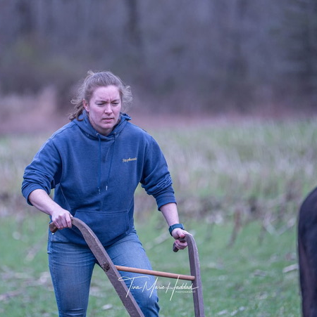
We are honored to dedicate this year's fair book to Stephanie Bellows. As a leader with the CT Whiplash Teamsters 4-H Club, she is passionate about sharing her knowledge of working steers. She makes time to talk to anyone who shows an interest in learning more about training a team. We are grateful to have such a dedicated leader to learn from and help us grow. Thank you, Stephanie, for everything you do to be a positive role model for Windham County 4-H and its members.

A message from our 2026 Windham County 4-H Fair Association President:

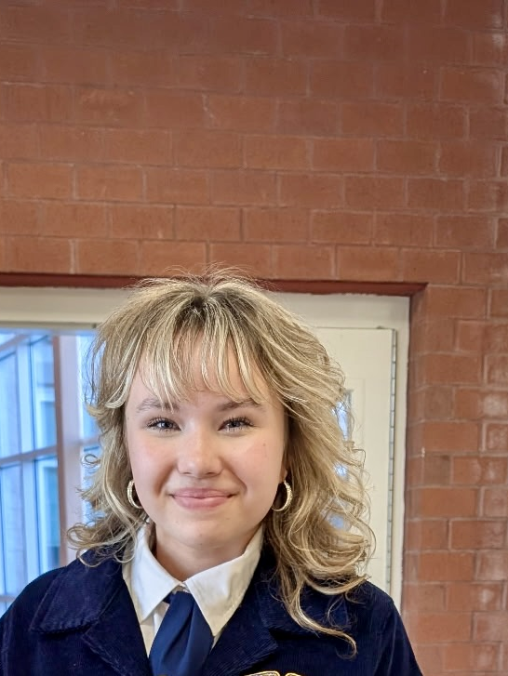
The Windham County 4-H Fair Association is honored to be holding the 2026 Windham County 4-H Fair. The 4-H members and leaders have collectively worked on creating a wonderful fair you don’t want to miss.
Our fair is a special opportunity to see all of the hard work and dedication the 4-Her’s have put into their projects. Whether it be working with animals, or using creative thinking for art, they deserve the utmost recognition for their hard work.
As 4-Her’s we couldn’t do what we do without our sponsors, parents, leaders, and fellow 4-Her’s. Thank you for all the help and support that is put into our fair. Let’s make this year the best one yet!
Sincerely,
Willow Deary
Windham County 4-H Fair Association President, 2026



What is Windham County 4-H?

UConn 4-H is the youth development program of UConn Extension. 4-H is a community of over six million young people across America who are learning Science, Technology, Engineering and Math (STEM), leadership, healthy living, civic engagement, and life skills through their 4-H project work.

For further information on the University of Connecticut Extension 4-H Program contact:

Bonnie Kegler
Assistant Extension Educator

Windham County Extension Center
139 Wolf Den Rd.
Brooklyn, CT 06234

Phone: 860-774-9600

Email: bonnie.kegler@uconn.edu

4-H is the youth development program of UConn Extension. As part of the College of Agriculture, Health and Natural Resources, we belong to a nationwide educational network through Cooperative Extension and the U.S. Department of Agriculture.

Table of Contents
Schedule of Events-------------------------------------------------------------------------------------------------------------------------------7
Exhibitor’s Dinner--------------------------------------------------------------------------------------------------------------------------------7 General Fair Rules & Regulations--------------------------------------------------------------------------------------------------------- 8-9

Home Show
Class 1 Record Books---------------------------------------------------------------------------------------------------------------------10
Class 2 Club Booths----------------------------------------------------------------------------------------------------------------------10
Class 3 Posters-----------------------------------------------------------------------------------------------------------------------------10
Class 4 Communications----------------------------------------------------------------------------------------------------------------11
Class 5 Baked Goods---------------------------------------------------------------------------------------------------------------------11
Class 6 Canning/ Food Preservation-------------------------------------------------------------------------------------------------12
Class 7 Eggs--------------------------------------------------------------------------------------------------------------------------------12
Class 8 Non-Food Animal Products--------------------------------------------------------------------------------------------------12
Class 9 Flowers-------------------------------------------------------------------------------------------------------------------------12-13
Class 10 Horticulture-------------------------------------------------------------------------------------------------------------------13
Class 11 Needlework-----------------------------------------------------------------------------------------------------------------13-14
Class 12 Clothing/ Sewing-------------------------------------------------------------------------------------------------------------14
Class 13 Artwork------------------------------------------------------------------------------------------------------------------------14
Class 14 Photography----------------------------------------------------------------------------------------------------------------14-15
Class 15 Collections---------------------------------------------------------------------------------------------------------------------15
Class 16 Scrapbooks--------------------------------------------------------------------------------------------------------------------15
Class 17 Hobbies & Crafts----------------------------------------------------------------------------------------------------------15-16
Class 18 Model Building & Rockets------------------------------------------------------------------------------------------------16
Class 19 Woodworking & Electrical------------------------------------------------------------------------------------------------16
Class 20 Computers--------------------------------------------------------------------------------------------------------------------16
Class 21 Recycled items-----------------------------------—-------------------------------------------------------------------------17
Association of CT Fairs Junior Baking Contest----------------------------------------------------------------------------------------------11
Association of CT Fairs Quilt Contest---------------------------------------------------------------------------------------------------------14
Animal Show
Livestock Exhibitor Rules & Regulations---------------------------------------------------------------------------------------------------17-18
2026 Connecticut Department of Agriculture - Fair and Show Requirements---------------------------------------------------18-23
Class 22 Dairy Cattle-----------------------------------------------------------------------------------------------------------------23-24
Class 23 Beef Cattle-------------------------------------------------------------------------------------------------------------------24
Class 24 Working Steers------------------------------------------------------------------------------------------------------------24-25
Class 25 Goats------------------------------------------------------------------------------------------------------------------------25-26
Class 26 Sheep------------------------------------------------------------------------------------------------------------------------26-27
Class 27 Poultry/Waterfowl-------------------------------------------------------------------------------------------------------27-28
Class 28 Pets-----------------------------------------------------------------------------------------------------------------------------28
Class 29 Rabbits & Guinea Pigs------------------------------------------------------------------------------------------------------28
Class 30 Swine------------------------------------------------------------------------------------------------------------------------- 28-29
Class 31 Horses--------------------------------------------------------------------------------------------------------------------------29
Premier Showmanship and Livestock Herdsmanship—---------------------------------------------------------------------------------30
Costume Contest and Obstacle Course------------------------------------------------------------------------------------------------------31
Outstanding Artisan Award---------------------------------------------------------------------------------------------------------------------38
Forms----------------------------------------------------------------------------------------------------------------------------------------------34-41

Windham County 4-H Fair Association 2025-2026 Officers

President: Willow Deary
Vice-President: Georgiana Young
Secretary: Adelise Young
Treasurer: Lydia Young
Communications: Delia Chmura

Superintendents

Beef: Lola Delgado

Dairy: Happy Herdsmen 4-H Club

Goats: Amanda Sawyer

Home Show: Krafty Kids 4-H Club

Horse: Amanda Sawyer

Poultry/Small Animals: Barnyard Buddies

Premier Showmanship: Willow Deary

Sheep: Grace & Olivia Syme

Working Steers: Whiplash Teamsters
_______________________________________

Exhibitor’s Dinner
Exhibitors, volunteers, and their families are invited to our annual potluck dinner.

When: Saturday, July 25th, at 6:30 p.m.
Where: Better Living Building

What to Bring: By the first letter of your last name A–M =Salads/Sides N-Z = Dessert

(The fair board will supply drinks, burgers, hot dogs, and condiments.)

Schedule of Events

Thursday July 23rd
5:00 pm Fairgrounds Set Up

Friday July 24th
2:30-3:00 pm Superintendents at the Fairgrounds
3:00-5:00 pm Home Show Check In & Animal
Arrival
5:00 pm Animals need to be stalled/penned
5:30 pm Home Show Judging
6:30 pm Opening Ceremonies
10:00 pm Gates Closed

Saturday July 25th
8:00 am Gates Open
8:00 am-11:00 am
Ekonk Community Grange
Hearty Farm Breakfast served
$8 adults and $5 children 8 years & under

9:00 am-3:00pm Vendors, Food Trucks,
Scavenger Hunt, Ag Displays

9:00 am Dairy Cattle & Goat Shows
10:00 am Working Steer Show
11:00 am Beef Cattle Show
12:00 pm Rabbit Show
1:00 pm Sheep Show
2:00 pm Horse Show
3.00 pm 4-H Animal Costume Contest
4:00 pm 4-H Animal Obstacle Course
6:30 pm Exhibitor’s Potluck Dinner
8:00 pm 4-H Battle of the Barns
10:00 pm Gates Closed

Sunday July 26th
8:00 am Gates Open
8:00 am Outstanding Artisan Contest Begins (Better Living Building)
9:30 am Premier Showmanship
12:00 pm Release of Non-Animal Exhibits
Following Recognition/Closing Ceremonies
Premier
2:30 pm Clean Up/Release of Animal Exhibits

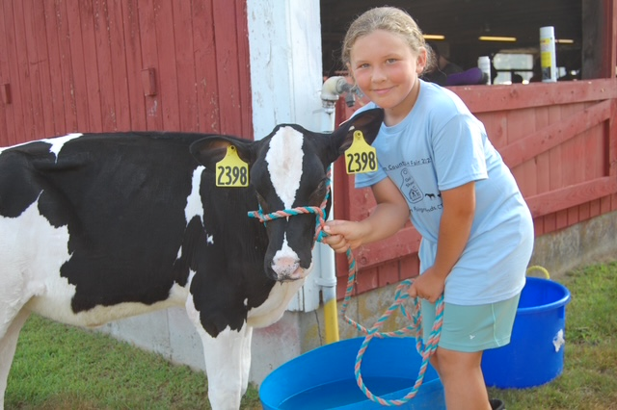General Fair Rules & Regulations
Exhibitor Requirements
- All Windham County 4-H members who are at least 7 years old, and not have reached their 19th birthday by January 1 of the current 4-H year may exhibit, unless otherwise specified in the class rules.

Out of County Exhibitor Requirements
- Animal entries will be accepted from all CT 4-H members while space is available. “Out of County” exhibitors are not eligible for participation in the premier showmanship contest.
“Out of County” 4-H members must follow all other rules and regulations, and complete all registration forms & include a photocopy of your approved verification form with your entries.

All Entries
- All 4-H members wishing to participate MUST ENTER by July 15th, by completing the Entry Forms located at the end of the fair book.
- All exhibits must be in place by 5:00 p.m. on Friday. Entry time is from 3-5:00 p.m. All exhibitors must report to the registration area in the Better Living Building prior to setting up any exhibit. Record books will be turned in at this time.
- Exhibits must be made or grown by the exhibitor since the last WC 4-H Fair; animals must be owned or leased by the exhibitor during the current 4-H year.
Animal Entries
Exhibitors showing any animals at the need to read the Animal Entry Rules & Regulations, including the CT Fair Regulations completely. They can be found at the beginning of the animal entries section.
4-H Record Books
- All exhibitors must enter their 4-H record book containing a completed “Activity Record”. Ribbons or trophies will not be awarded to 4-Hers without submitting a record book.
Any 4-H member who wishes to exhibit their 4-H animal project must have submitted an animal project record for that species & must have also submitted the appropriate 4-H Animal Project Verification Forms to the 4-H Office by June 1, of the current 4-H year (May 1st for dairy, beef , working steers and horses) in order to exhibit their animal(s).
- Exhibitors wishing to submit Home Show entries need to complete project records ONLY for those entries which were part of ongoing 4-H projects. (i.e. made/grown over the course of several months or multiple meetings.)
Judging
No person may interfere with judges while in discharge of their duties. Any person so interfering will be excluded from competition. Superintendents from each department will remain in the building to assist judges. The Danish system is the primary system of judging. Each exhibit is evaluated by the judge on its own merit and is not compared to others in the same lot. Evaluation is based on the quality of the exhibit with consideration to the exhibitor’s age and experience in the project. Blue (B) signifies excellent, Red (R) very good and White (W) good.
In all cases, the decision of the judge(s) is final.

Dress Code
- Exhibitors & volunteers are reminded that anyone wearing clothing deemed inappropriate by show advisors will be asked to change immediately or be asked to leave the grounds. This includes but is not limited to: revealing clothing, flip-flops in the animal barns/areas and clothing items with offensive subject matter on them.

Exhibit Safety
- During the fair all exhibits are under the direction of the 4-H Fair Association which will use due precaution for the safety of all exhibits. In no case will the Windham County 4-H Fair Association, Windham County Agricultural Society or management be responsible for any loss or damage that may occur.
- Each exhibitor and their parent/guardian (as well as owner of leased animals) will be solely responsible for any loss, injury or damage to any animal; or loss, injury or damage done by or arising from any animals exhibited by him/her and shall indemnify said Fair Associations against legal or other proceedings in regard there to. All exhibitors should give personal attention to their property.

Overnight Stays
- Exhibitors who have signed parental consent forms found at the end of this book may stay on fairgrounds overnight. Provided, there is at least one adult from the member’s club present who will be the emergency contact responsible for them.
- All youth staying overnight must check in daily with the overnight director.
- No one staying overnight is allowed to leave the fairgrounds without the permission of the overnight director.

Removal of Exhibits
- All exhibits must remain in place until 12:00 p.m.
on Sunday and should be removed by 2:00 p.m. Items not taken at the appropriate time will be disposed of at the discretion of the 4-H Fair Association.
Each person exhibiting will be given a clean-up task to complete before being signed out by the
superintendent of that building and having their exhibit(s) released. 4-Hers exhibiting livestock are also expected to break down enclosures used for their animal(s) and remove all bedding.

Safety Precautions
- Safety precautions are to be observed at all times. Any person causing risk of injury to himself, other exhibitors or spectators will be asked to leave the fairgrounds.

Non-Show Animals
- No animals other than those being shown will be allowed on the fairgrounds, with the exception of personal assistance animals.

Biohazard Precautions
- Exhibitors should observe hand washing signs and be a constant safety example for the general public.

Fairgrounds
- No alcoholic beverages or illegal drugs are allowed on the fairgrounds.
- No smoking in the barn areas or buildings.

Premiums
Animals (including costume contest):
- 1st Place - $10
- 2nd Place - $8
- 3rd - $6
- 4th - 6th - $2
- Champion - $10
- Reserve - $8
- Honorable Mention - $6

Home Show (including record books)
- Blue - $3
- Red - $2
- White - $1
- Best in Show - $10

Premier Showmanship
- 1st Place - $20
- 2nd Place - $15
- 3rd Place - $10
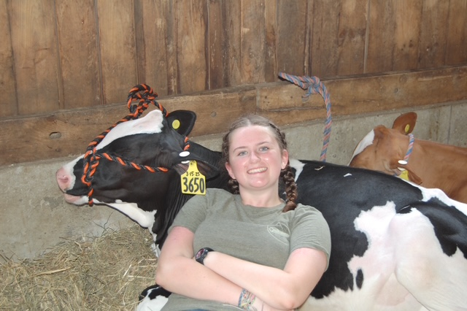
- 4th-10th Place - $5

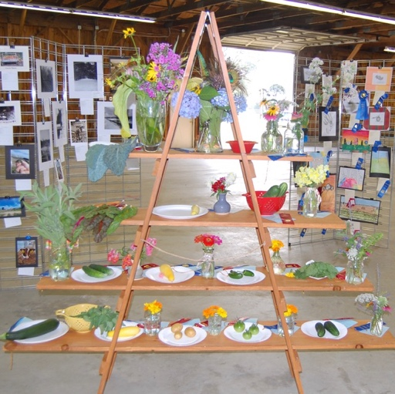

Home Show
- Exhibitors must follow all rules listed in the General Fair Rules and Regulations section and all exhibits must conform to those rules as well.
- Entries will be judged based on the Danish system & an overall winner will be selected for each class as well as grand champion entries for the Home Show.

Class 1 – Record Books
- Should include an activity record & all individual project record sheets.
- Forms should be bound in a notebook or report folder with the current year on top. Members are asked to keep records for all years in one notebook.
- Do not include photographs, certificates, news clippings, etc. unless asked for in the records since these belong in a scrapbook.
- All record books should be reviewed for completion by the club leader or designee prior to entry in the fair.

Lot # Lot Description
1 Novice, (7-8 years old, 1st year member)
2 Junior (9-13 years old)
3 Senior (14-19 years old)

Class 2 - Club Booths
- This is a club project. Club members must work together to show the public what they are learning in their club. The booth may include a list of club members (optional).
- No individual entries will be accepted.
- Must be a free standing exhibit.
- Booths must be educational in nature.
Club Booths will be judged on:
- Educational Value - One main idea; message expressed simply & clearly; related to 4-H program; encourages viewer action or decision; teaches a worthwhile lesson
- Interest & Originality - Catchy title or caption; everything contributes to the main idea; idea presented in an interesting way; attracts and holds attention.
- Appearance & Attractiveness - Neat, well balanced arrangement; attractive color combinations; lettering neat and easy to read; well- proportioned display; appropriate background material
- Further Information - Handouts supplied (if appropriate)
Class 3 - Posters
- Posters should be on one sheet of poster board.
- Put name, age and category entered on the back of the poster.
Posters will be judged on:
Subject – One main idea, accurate information, should present a simple but clear message.
Public Appeal – Arouses interest and holds attention.
Attractiveness – Neat, simple, easy to read.
Originality – Presented in an innovative way
Lot # Lot Description
1 Animal subject matter
2 Environmental subject matter
3 All other subject matters

Class 4 - Communications
- Please make work legible. It is suggested that work be typed and double spaced.
- All work will be evaluated on content, correctness, and presentation.
Communication material will be judged on:
Interesting content Clear story elements
- Logically organized – Nice and easy to read
- Original presentation - Good arrangement & use of media
- Appropriate and accurate information
Lot # Lot Description
1 Original Essay – 10 page max
2 Original research report – 10 page max
3 Original short story
4 Original poetry collection- 10 pieces
5 All other written works – 10 page max

Class 5 – Baked Goods
- Baked goods must include a complete recipe card, giving exact name of product & all ingredients. May be photocopied.
- Recipe cards must be included and directions must be followed accurately.
- All entries should be submitted on/in disposable dishes. The Fair Association will not be responsible for non- disposable dishes left with food for exhibit.
Baked goods will be judged on:
  - Pleasing appearance, pleasant presentation, good shape and size
Appropriate texture, enjoyable flavor
  - Demonstrated appropriate food safety practices

Lot # Lot Description
1 Cakes or cupcakes
2 Cookies
3 Decorated baked goods
4 Yeast breads/rolls
5 Muffins/ quick breads
6 Pies (any types; must not require
refrigeration)
7 Candy/fudge
8 All other foods
9 Assoc. of CT Fairs Jr. Baking Contest
10 Assoc. of CT Fairs Adult Baking Contest
11 Assoc. of CT Fairs Two Crusted Apple Pie

Association of Connecticut Fairs Baking Contest
The Junior Baking Contest is open to juniors between the ages of 7 and 15 as of July 1st. There will be one group for both local and state contests. A first place ribbon will be awarded to the winning entry. In the event the first place winner will not be able to compete at the state contests (held as part of the Fall Meeting and Convention of the Association of Connecticut Fairs), the second place winner will be allowed to represent the fair.
4-H members at the Windham County 4-H Fair can compete in the following baking contests:
- 2026 Jr. Baking Contest Recipe – S’more Granola Bars
- 2026 Adult Baking Contest Recipe – Lemon Bliss Cake
- Two Crusted Apple Pie Contest – Rules have been updated for 2026

Full contest rules, prizes, and recipes can be found at the Association of CT Fairs website at www.ctagfairs.org .

Class 6 – Canning/ Food Preservation
- An exhibitor may enter more than one exhibit in a lot, provided they are not exactly the same. All entries must have been canned since the previous 4-H Fair.
- Paste a label on each jar stating: name of product, date processed, and method of processing.
- It is required that low acid vegetables, meats, fish, and poultry be processed in a pressure canner to insure against spoilage or food poisoning. Fruits and acid vegetables, tomatoes and pickles must be water bath canned.
- Canned fruits, vegetables, and sauces will be judged on: condition of product, liquid, proper packing, and cleanliness of jar. These will not be opened.
- Jams, jellies/preserves, syrups, and honeys will be judged on: color, clearness, flavor, texture and condition. These must be processed in a water bath and will be opened.
- Paraffin seals are not accepted.
- Clear glass is required as it shows the product better than colored glass.
Canned goods will be judged on:
Clean, neat appearance Good color & texture
Proper seal and label use - (neat and accurate label), no signs of foreign matter, and no signs of spoilage
Proper preservation method used
Lot # Lot Description
1 (1) Jar of fruit
2 (1) Jar of vegetables (includes pickles/
relishes)
3 (1) Jar of jelly, jam, marmalade or
preserves
4 (1) Jar of specials (includes maple syrup
and honey)
5 (1) Jar of sauce (includes spaghetti sauce,
salsa, and other)

Class 7 - Eggs
- All entries to consist of one dozen eggs
- One egg per entry will be broken for judging.
Eggs will be judged on:
Clean, neat appearance Even color and texture
Appropriate shape and size
Shells unbroken and uncracked
Good internal appearance No foul smells or signs of spoilage
Lot # Lot Description
1 Brown chicken eggs
2 White chicken eggs
3 Any other colored chicken eggs
4 Bantam chicken eggs
5 Any other bird eggs

Class 8 - Non-Food Animal Products
- All articles must be made from raw materials derived from the exhibitor's own animal(s).
Articles will be judged on:
Quality workmanship – Quality materials used
Good color and texture
Appropriately constructed
Good overall appearance, well balanced design, and effective presentation
Suitability
Lot # Lot Description
1 Spun Yarn
2 Knitted or crocheted item
3 Other items made from animal products

Class 9 - Flowers
- All exhibits must be grown and selected by the exhibitor, unless otherwise stated.
- All flowers must be arranged in a container supplied by the exhibitor. The container should be suitable for specimens being exhibited.
- No artificial flowers or foliage of any kind are permitted.
- Accessories may be used in any of the arrangement lots.
Exhibits will be judged on:
- Uniformity – Size, color, stem quality
- Condition – Freshness, maturity, arrangement
- Freedom from blemishes, pests, disease, weather and handling damage
Lot # Lot Description
1 Large dahlia, large marigold, standard rose
(1 specimen)
2 Aster, pom pom, small dahlia, salvia, sweet pea (3 specimens)
3 Small marigold, small zinnia, cosmos,
bachelor’s buttons, miniature/tea rose (4
specimens)
4 All other flowers (appropriate # of
specimens)

Class 10 - Horticulture
All exhibits must be grown and selected by the exhibitor. All vegetables will be exhibited on white paper plates supplied by the WIndham County 4-H Fair Association.
Exhibits will be judged on:
Uniform size, shape, and color
- Fresh, mature specimens
- Pleasant arrangement and appearance (no signs of rot)
- Effective presentation
- Free of pests, disease, and other marks from handling
Lot # Lot Description
1 Broccoli/ cauliflower – 1 head
2 Lettuce – 1 head/plant
3 Tomatoes – 3 green, red, yellow (same
variety)
4 Kale – 1 head
5 Eggplant – 1
6 Squash – 1 (any variety)
7 Celery – 1
8 Cabbage – 1 head
9 Peppers – 3 (same variety, any type)
10 Collards – 1 bunch
11 Pumpkin – 1
12 Cucumber – 2 (same variety, any type)
13 Gourds – 2 (fresh or dried)
14 Beets – 3 (same variety, any type)
15 Carrots – 3 (same variety, any type)
16 Parsnips – 3 (same variety, any type)
17 Potatoes – 3 (same variety, any type)
18 Corn – 3 ears (same variety, any type)
19 Radishes – 3 (same variety, any type)
20 Beans – 5 pods (same variety, any type)
21 Any other vegetable not listed above
22 Any variety of herb or spice – 3 stems
23 Melons – 1 melon any variety
24 Tree fruits – 3 (same variety, any type)
25 Any other fruit variety not listed above
26 Fruit and vegetable collections (6 items)
27 Fruit, vegetable, and herb art

Class 11 - Needlework
- Article must have been made in the current 4-H year.
Articles will be judged on:
- Quality of workmanship and suitability
- Appropriate construction method - Demonstrated as well as a clean and neat construction
- Even stitches, well blocked seams
- Innovative design
- Good overall appearance

Lot # Lot Description
1 Crocheted or knitted blanket
2 Crocheted or knitted sweater
3 Crocheted article
4 Knitted article
5 Hooked article
6 Embroidered article, needlepoint,
cross-stitch or mixed needlework
7 All other needlework
8 Quilt or quilted item (hand or machine
sewn)
9 Association of CT Fairs Quilt Contest
Association of Connecticut Fairs QUILT CONTEST complete rules can be found at www.ctfairs.org.

Class 12 - Clothing and Sewing
  - Include pattern envelope and instruction sheet with all garments.
  - Any exhibit not clean or pressed properly will be disqualified.
  - Bring a hanger for garments.
Articles will be judged on:
  - Quality workmanship and suitability
  - Even stitches, seams, hems, etc.
  - Clean, neat construction
  - Innovative design
  - Good overall appearance
  - Pressed and nicely presented
Lot # Lot Description
1 Bag
2 Apron
3 Skirt
4 Blouse/Shirt
5 Dress
6 Accessory – hat, scarf, etc.
7 All other articles of clothing
8 Doll or toy
9 Home article – pillow, curtains, etc.

Class 13 - Artwork
Articles must have been made in the current 4-H year.
All pictures and paintings must be mounted.
Limit four (4) exhibits per lot
Artwork will be judged on:
Attractive composition Media used appropriately
Good use of color/texture Well organized
Clean and neat presentation Innovative design
Creative execution of finished work
Lot # Lot Description
1 Original painting
2 Original drawing
3 Original mixed media
4 Original collage
5 Original sculpture
6 All other artwork

Class 14 - Photography
Photographs must have been taken by the 4-H member after entries closed for the previous Windham County 4-H Fair.
All photographs must be matted and mounted or neatly mounted on heavy paper and labeled.
All photographs must be captioned. Put the title on front of the exhibit.
For Lot 7, a “before” picture of the image prior to enhancing must be attached to the back of mount; “before” picture does not need to be captioned.
Limit (3) entries per lot.
Entries to be split as noted; please indicate by adding appropriate letter to lot # on entry form.
A - Color Prints
B - Black and white prints

Photography will be judged on:
Attractive composition
Good representation of subject matter
Good use of light/shadows Well organized
Clean, neat presentation Innovative design
Good overall appearance Conveys a story
Lot # Lot Description
1 Person/people
2 Domestic Animal
3 Wild animals/nature
4 Action/sports
5 Landscapes
6 Photojournalism
7 Creative interpretation of photo
8 Any other photograph

Class 15 - Collections
- Exhibitors must provide a written description of the collection. If entered in previous years, include what has been added or altered this year to create a significant change.
Limit (1) collection per exhibitor.
Each exhibit must be a current collection and must belong to the 4-H member.
Exhibits will be judged on:
Attractive composition Clear theme
Materials effectively used
Well organized
Clean, neat presentation
Method of display (originality/creativity)
Inclusion of written description
Must have a minimum of eight (8) items
Lot # Lot Description
1 Novice (7-8 years old)
2 Junior (9-12 years old)
3 Senior (13-19 years old)

Class 16 - Scrapbooks
Scrapbooks should be attractive, neat and logically arranged
Scrapbooks will be judged on:
- Attractive composition
- Clear theme
- Materials effectively used
Well organized
Clean, neat presentation
Logically arranged
Conveys a story
Demonstrates creative thinking
Lot # Lot Description
1 Scrapbook – subject related to 4-H
2 Scrapbook – any other subject matter
3 Club Scrapbook – to be entered under club name

Class 17 - Hobbies & Crafts
Items may not be entered in the same lot if they are identical.
Articles must be clean and intact.
All articles must be ORIGINAL.
Limit (4) entries per lot.
Items will be judged on:
Attractive composition
Well balanced design
Materials effectively used
Well organized
Clean, neat presentation
Good use of color/texture
Effective construction
Demonstrates creativity and resourcefulness

Lot # Lot Description
1 Weaving
2 Jewelry
3 Paper craft
4 Metal craft
5 Tie-dying
6 Beadwork
7 Diorama
8 Sculptures/clay
9 Stained glass
10 All other crafts

Class 18 - Model Building & Rockets
A 3x5 card must accompany each exhibit explaining exactly what the exhibitor did to complete the project.
Directions should be included if from a kit.
Description should be included if original design.
Items will be judged on:
Attractive composition
Well balanced design
Materials effectively used
Proper Construction
Clean, neat presentation
Good use of color/texture
Explanation included
Demonstrates creativity and resourcefulness
Lot # Lot Description
1 Vehicles
2 Buildings
3 People and/or animal
4 All other models
5 Rocketry
6 Robotics

Class 19 - Woodworking & Electrical
Projects too large may be entered by photo documentation and a written description
Projects will be judged on:
Quality workmanship Materials effectively used
Proper construction Clean, neat presentation
Suitable for intended purpose Sturdy and safe
Lot # Lot Description
1 Birdhouse or Feeder
2 Other small woodworking project
3 Carved wooden object
4 Piece of furniture
5 Other large woodworking project
6 Homemade electrical project
7 Electrical project from kit
8 Any other electrical project

Class 20 - Computers
- Must be original work.
Computers will be judged on:
Attractive composition Understands technology
Materials effectively used Well balanced design
Clean, neat presentation Evidence of effort
Demonstrates creativity
Lot # Lot Description
1 Original computer art-printed and
mounted
2 Digitally manipulated image – include a
copy of original image
3 Original web page – printed out
4 Original application (game, program, etc.)
– provide a detailed written description
5 Original presentation – printed out
6 Hardware configuration design – provide a detailed written description
7 Computer case modification – artistic
changes (include “before” picture) or
custom built

Class 21- Recycled Items
Recycled means reusing an existing item in a new way.

Lot # Lot Description
1 Youth
2 Adult

Please see Page 38 to enter
Outstanding Artisan

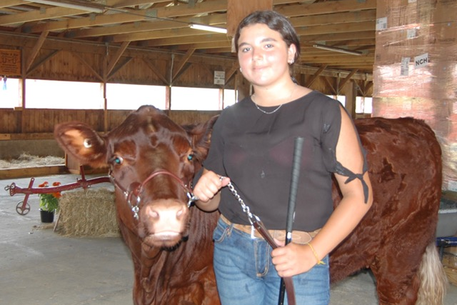
General Information - Livestock Exhibitors

Exhibitors
- Exhibitors must follow all rules listed in the General Fair Rules and Regulations Section and all exhibits must conform to those rules as well.
Animal Health
- Please read the CT Fair & Health Regulations listed in the livestock section of this fair book. All regulations must be met in order to show. Call the CT Department of Agriculture at (860) 713-2504 if you have questions.
- Interstate permits are required if entry comes from out of state.

Set-up/Arrival of Exhibits
- Upon arrival, take your record book and animals’ health papers to the respective livestock superintendent. No animals may be unloaded until papers are checked. Animals with obvious warts or ringworm and extremely dirty animals will be refused entry. Any animal with a “suspicious condition” will be isolated until it can be checked by a Veterinarian at the owners expense. Their decision will be final.
- Initial bedding will be provided by the 4-H Fair if donated. Exhibitors must supply their own additional bedding if supplies run low.
- Pens and tie-ups will be assigned by the barn set-up committee and superintendents.
- Due to the CT Rabies Advisory, animals for which there is no licensed rabies vaccine and those too young to be vaccinated will be exhibited by a double barrier.

Animal Care
- Once animals are on the fairgrounds and unloaded, only 4- Hers will work on and care for their animals. This is a 4-H exhibit. Each exhibitor is responsible for the care of his/her animal(s) and any damage done. All animals must be raised and shown by the 4-H member using safe and currently approved agricultural practices.
- Once animals are safely unloaded, 4-H members are required to take full responsibility for care, feeding, clipping, blocking and showing. Senior 4-H members are asked to help younger members as needed. Any adults assisting will be asked by the superintendents and advisors to stop unless there is an issue of safety.

Wash Racks
- Livestock exhibitors planning to use wash racks must bring their own hose equipped with a shut off nozzle and leave the wash rack clean when done washing.
Showing/Judging
- All animal exhibitors must enter fitting and showmanship.
- Members with more than one animal in a class may have another 4-H member help show.
- Classes will be judged on the Dual Merit System, a combination of Standard and Danish. Entries will be lined up and Danish awards (blue, red, white) will be given in groupings.
- Single animal entries are limited to 3 per lot number per exhibitor, except group classes where only one entry is permitted.
- Classes may be split at the discretion of the superintendent or the judge.
Dress Code
- In the interest of safety, no exhibitor should be working in the barn areas or around large animals with open toed shoes, flip flops or barefoot at any time.
- Proper show clothes, including appropriate footwear, are mandatory in all livestock classes and should be neat & clean. For the purposes of this fair the dress code is as follows:
- Showmanship- White shirt & khaki, white, dark blue, green or black long pants or as appropriate for species shown.

- All Other Classes & Premier Showmanship
2026 Sponsorship T-Shirt &
khaki, white, dark blue, green or black long pants.

Clean-up
- Animals will not be released until the barns and surrounding areas have been cleaned. Bring your own equipment.
- General clean-up assignments will be made by the superintendents.
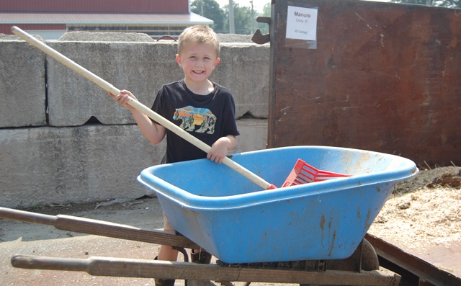

DEPARTMENT OF AGRICULTURE BUREAU OF REGULATION AND INSPECTION
2026 CONNECTICUT FAIR AND SHOW REQUIREMENTS

FEDERAL ORDER
Effective April 29, 2024, all lactating dairy cattle must receive a negative test for Influenza A virus
at an approved National Animal Health Laboratory Network (NAHLN) laboratory for interstate
movement.1 Currently, the Connecticut Veterinary Medical Diagnostic Laboratory (CVMDL) at
UCONN is the only approved NAHLN laboratory in New England.2 Milk samples must be collected
and submitted by the same Category II accredited veterinarian who is completing the health
certificate and must be collected no more than seven (7) days prior to interstate movement.1
Lactating dairy cattle from herds which have tested positive for Influenza A are not eligible for
movement for thirty (30) days from the most recent collection of any sample that tests positive
from any individual animal in the herd. After the 30-day period, animals must be tested again for
movement. No dairy cattle exhibiting- clinical signs of HPAI will be allowed to move into
Connecticut.1

GENERAL REQUIREMENTS FOR ALL ANIMALS
1. All animal competitors may be blood tested for banned substances.
2. Certificate of Veterinary Inspection (CVI) (aka Health Certificate), signed by an accredited
veterinarian, and other required testing will be valid for the entire 2026 show season. If
traveling to multiple New England States for exhibition, see the Memorandum – 2026
New England Fairs and Shows for additional requirements.

3. All animals and poultry entered at fairs and shows must be in good health and in proper
physical condition and will be examined at the exhibition by the barn superintendent.
Evidence of poor condition or infectious or contagious disease, or failure to produce the
necessary documents for health certification, vaccination, or testing will result in
ejection. The Connecticut Department of Agriculture (DoAg) Livestock Inspector's
decision is final.

4. CVI issued within 60 days of first show (or in accordance with the NE fair agreement), and
proof of vaccination where applicable, are the responsibility of exhibitors, competitors,
and special attractions (petting zoos, etc.). A physical copy of the CVI must be provided to
fair superintendents (printed eCVI or owner’s copy of paper CVI).

5. Each barn superintendent will collect and hold CVIs from each exhibitor, competitor, and
special attractions. Animals not in compliance with state regulations for shows and fairs
will not be allowed. A complete list (exhibitor name, address, animal’s official USDA ID —
ear tag, tattoo, or microchip; breed, age, and total head count) will be made available to
the State Livestock Inspector and forwarded to the DoAg Bureau of Regulatory Services
by the fair superintendent. All animals and poultry present on the grounds shall be
identified on this list. Any animal that is rejected should be noted as such with a brief
statement of reason. Rejected animals or poultry should be removed from the grounds as
soon as possible. Any concerns about the health of any animal or bird should be reported
to the State Livestock Inspector or the Fair Veterinarian immediately.

6. All exhibited animals and poultry should be isolated from Home Farm animals and poultry
after the show. DoAg recommends a 3–4-week isolation period to help reduce the risk of
disease exposure and transmission contracted while at the fair or show. Call your local
veterinarian if your animals or poultry display symptoms of illness.

REQUIREMENTS FOR IN-STATE CONNECTICUT ANIMALS
Rabies (In-State)
All cattle, horses, sheep, and dogs must have a rabies vaccination given by a licensed veterinarian.
The vaccination certificate must be signed by the veterinarian who administered the vaccine and
include the animal’s identification and description, the name of the vaccine’s manufacturer, serial
number, and the date the vaccination was given and when it expires. If it is the animal's first
rabies vaccination, it must be given at least 30 DAYS prior to their first show date to be
considered current.

ALL SPECIES
Animals must originate from herds or flocks that meet the testing and health requirements of the
State of Connecticut. State livestock inspectors may request proof of compliance. No herd or
flock under quarantine shall move or be exhibited. All animals must have permanent official USDA
identification (ear tag, tattoo, or microchip; horses must retain Coggins / EIA documentation as
applicable)

CATTLE (including OXEN)
All cattle must have an approved official USDA identification and be accompanied by a CVI issued
within 60 days of first show (or per NE fair agreement) by an accredited veterinarian stating that
the animal is in good health and not showing signs of infectious, contagious, and/or
communicable diseases.

HORSES / PONIES
All horses must have a negative test for Equine Infectious Anemia (EIA) within 12 months of the
show date and be accompanied by the Coggins certificate AND a CVI issued within 60 days of the
first show date (or per NE fair agreement). EIA testing may be AGID or ELISA. The equine standard
of care strongly recommends vaccination against EEE, WNV, Influenza, and Rhinotracheitis within
6 months of the first show date.
All pulling horse/pony competitors must have a microchip.

SHEEP
All sheep must have an approved official USDA identification and be accompanied by a CVI issued
within 60 days of the first show date (or per NE fair agreement) by an accredited veterinarian
stating that the sheep are in good health and not showing signs of infectious, contagious, and/or
communicable diseases and are not from Scrapie exposed- flocks.

GOATS
All goats must have an approved official USDA identification, and a CVI issued within 60 days of
first show date (or per NE fair agreement) by an accredited veterinarian stating that the animals
are in good health and not showing signs of infectious, contagious, and/or communicable
diseases and are not from Scrapie exposed- herds.

SWINE
All swine must have an approved official USDA identification, and a CVI issued within 60 days of
first show date (or per NE fair agreement) by an accredited veterinarian. All swine must also
originate from Connecticut herds that are tested for Brucellosis and Pseudo-rabies on a yearly
2basis per statutory requirement.
If the swine is purchased from a tested herd, a bill of sale from the Connecticut producer must be
presented to the State Veterinarian’s office before a Connecticut Exhibition Test card will be
issued to the new owner.

POULTRY
Poultry originating within the state must come from healthy flocks with no evidence of infectious,
contagious, and/or communicable diseases. All birds must be inspected, identified, and
accompanied by written proof (Connecticut Veterinary Medical Diagnostic Laboratory Report)
verifying the individual birds listed were blood tested negative- for Salmonella pullorum within
365 days of the show date or proof that the bird originated from a USDA NPIP flock.2,6 Avian
Influenza testing of the flock and / or individual birds is required. All cages, crates, or vehicles
used for housing or transporting poultry must be cleaned and disinfected before and after each
show. Doves and pigeons are exempt from testing requirements but must be identified by CT
Department of Agriculture within 365 days of the show date. Waterfowl are not allowed to be
shown or displayed for the 2026 Fair & Show Season.

LLAMAS & ALPACAS
Llamas and alpacas that originate within the state must have a CVI issued within 60 days of the
first show date (or per NE fair agreement) by an accredited veterinarian listing the permanent
identification (ear tag, tattoo, or microchip) and stating the animal is in good health and free of
obvious signs of infectious disease.

RABBITS
All rabbits must have a CVI issued within 60 days of the first show date (or per NE fair agreement)
by an accredited veterinarian stating that the animal is in good health and not showing signs of
infectious, contagious, and/or communicable diseases including Rabbit Hemorrhagic Disease
(RHD). Rabbits must have a permanent identification number in the left ear (tattoo or may be micro-chipped behind the left ear). The identification number must match the animal’s number on the CVI. Rabbits are exempt from needing a rabies vaccination. Official ARBA Show Rules,Section 26.7

DOGS
All dogs must have a CVI issued within 60 days of the first show date (or per NE fair agreement)
which states the animal is in good health and free of obvious signs of infectious, contagious,
and/or communicable diseases. All dogs over 3 months of age shall be properly vaccinated for
rabies (mandatory) and DAHLP+B (Distemper, Adenovirus, Hepatitis, Leptospirosis, Parvovirus,
Bordetella) (highly recommended). Proof of vaccination and a valid CT Dog License is required.
Dogs must wear a collar and a 2026 Dog License tag. The licensing tag serves as the official
identification of the dog.

REQUIREMENTS FOR OUT-OF-STATE ANIMALS
Rabies (Out of- -State)
All cattle, horses, sheep, and dogs must have a rabies vaccination given by a licensed veterinarian.
The vaccination certificate must be signed by the veterinarian who administered the vaccine and
include the animal’s identification and description, the name of the vaccine’s manufacturer, serial
number, and the date the vaccination was given and when it expires. If it is the animal's first
rabies vaccination, it must be given at least 30 DAYS prior to their first show date.

ALL SPECIES
Animals shall originate from herds or flocks that meet the animal import testing and health
requirements of the State of Connecticut and must be accompanied by a CVI within 60 days of
the first show (or per NE fair agreement). No animals from a herd or flock under quarantine order
shall enter the State. All animals must have permanent official USDA identification (ear tag,
tattoo, microchip, or Equine Infectious Anemia (EIA) certificate). Poultry identification can include
leg and/or wing bands.4
• Exhibition permits: All livestock species and birds must have an exhibition permit number
on the health certificates.
Call 860-713--2504 or 860--713---2508 for a permit number.
All out of- -state animals and birds offered for sale must meet Connecticut Animal
Importation Regulations.

CATTLE / OXEN
All cattle must have an approved official USDA identification and be accompanied by a CVI issued
within 60 days of their first show (or per NE fair agreement) by an accredited veterinarian stating
that the animal is in good health and not showing signs of infectious, contagious, and/or
communicable diseases.4
All cattle must have a negative TB test within 12 months of the show date. Cattle under 6 months
of age may go on the dam's TB test chart if the dam was tested for TB within the past 12 months
and a copy of the results is provided. All Brucellosis vaccinated female cattle over 18 months of
age and all bulls and non-vaccinated female cattle 6 months of age and older must have a
negative Brucellosis test within 12 months of the show date. Steers and spayed heifers are
exempt from Brucellosis testing.4
Lactating Dairy Cattle (Out of- -State)
All lactating dairy cattle are required to receive a negative test for Influenza A virus at an
approved NAHLN laboratory for interstate movement. Milk samples must be collected and
submitted by the same Category II accredited veterinarian who is completing the health
certificate and must be collected no more than seven (7) days prior to interstate movement.
Lactating dairy cattle from herds which have tested positive for Influenza A are not eligible for
movement for thirty (30) days from the most recent collection of any sample that tests positive
from any individual animal in the herd. After the 30-day period, animals must be tested again for
movement. No dairy cattle exhibiting- clinical signs of HPAI will be allowed to move into
Connecticut.

HORSES / PONIES
All horses must have a negative test for Equine Infectious Anemia (EIA) within 12 months of their
show date (AGID or ELISA). The animal must be accompanied by a paper Coggins certificate AND
a CVI issued within 60 days of the first show date (or per NE fair agreement). The standard of
veterinary care strongly recommends vaccination against EEE, WNV, Influenza, and
4Rhinotracheitis within 6 months of the first show date.
All pulling horse/pony competitors must have a microchip.

SHEEP
All sheep must have approved official USDA identification and be accompanied with a CVI issued within 60 days of the first show date (or per NE fair agreement) by an accredited veterinarian
stating that the sheep are in good health and not showing signs of infectious, contagious, and/or
communicable diseases and are not from Scrapie exposed- flocks.

GOATS
All goats must have approved official USDA identification and be accompanied by a CVI issued
within 60 days of their first show date (or per NE fair agreement) by an accredited veterinarian
stating that the goats are in good health and not showing signs of infectious, contagious, and / or
communicable diseases and are not from Scrapie exposed- flocks.5 All goats must originate from
Brucellosis and TB free- herds. Goats 3 months old and over must test negative to TB and
Brucellosis within 12 months of the show date. Kids under 3 months of age may go on the dam's
test chart if the dam was tested within the past 12 months and a copy of the results is provided.
Wethers are exempt from Brucellosis testing.

SWINE
All swine must have an approved official USDA identification, and a CVI issued within 60 days
prior to the first show (or per NE fair agreement) by an accredited veterinarian. Swine that are 3
months of age and older must be negative to Brucellosis and Pseudorabies tests. Barrows are
exempt from Brucellosis testing but must have a negative Pseudorabies test. Piglets under 3
months of age may go on the sow’s testing chart if the sow was tested and originated from a
Brucellosis-free and Pseudorabies--free herd and must be on the CVI.

POULTRY
All poultry must be identified and test negative for Salmonella pullorum within 12 months of the
show date and be accompanied by this certificate. All poultry must comply with the Department
of Agriculture Avian Influenza (AI) requirements, originating from AI Free flocks or be tested for AI
within 30 days of entry and have a certificate. No poultry from any areas of any state having
Avian Influenza may enter Connecticut. All cages, crates, and vehicles used for housing and
transporting poultry must be cleaned and disinfected before and after each show. Doves and
pigeons are exempt from testing requirements but must be identified by leg bands or wing tags.
Waterfowl are not allowed to be shown or displayed for the 2026 Fair & Show Season.

LLAMAS & ALPACAS
All llamas and alpacas must have a negative Axillary TB test within 12 months and a negative
Brucellosis test within 12 months of entry, and a CVI issued within 60 days of the first show (or
per NE fair agreement) by an accredited veterinarian, listing the permanent identification (ear tag, tattoo, or microchip) and test results.

RABBITS
All rabbits must have a CVI issued within 60 days of their first show (or per NE fair agreement) by
an accredited veterinarian stating that the animal is in good health and not showing signs of
infectious, contagious, and / or communicable diseases including RHD. Rabbits must have a
permanent identification number in the left ear (tattoo or may be chipped behind left ear). The
5identification number must match the animal’s number on the CVI. Rabbits are exempt from
needing a rabies vaccination. Official ARBA Show Rules, Section 26.7

DOGS
All dogs must have a CVI issued within 60 days of the first show (or per NE fair agreement) by an
accredited veterinarian stating the animal is in good health and free of obvious signs of infectious,
contagious, and/or communicable diseases. All dogs over 3 months of age shall be properly
vaccinated for rabies (mandatory) and DAHLP+B (highly recommended). Proof of vaccination and
a valid STATE Dog License is required. Dogs must wear a collar and a current Dog License tag. The
licensing tag serves as the official identification of the dog.

IMPORTANT NOTICE –
RABIES IN PUBLIC SETTINGS

All animals for which there is a licensed rabies vaccine (cattle, horses, sheep, dogs, cats, and
ferrets exposed to the public) shall be vaccinated against rabies. Animals not having an approved
rabies vaccination shall be displayed in a manner such that the public would not be in contact or
exposed to saliva from those animals or have clearly visible posted signs or tape stating:
“CONNECTICUT RABIES ADVISORY NOTICE - DO NOT FEED OR TOUCH ANIMALS.”

On August 4, 2009, the Department of Agriculture adopted regulations for the “Control of Rabies
in Public Settings” which will be enforced at all Connecticut fairs and public exhibitions. The
complete text of the regulations, RCSA §§ 22-359-1 through 22-359-5, follows this notice.
Provisions (apply to instate and out- of- -state animals):

Animals with a licensed rabies vaccine
1. Horses, cattle, sheep, dogs, and cats must be currently vaccinated against rabies by a
licensed veterinarian unless they are under the minimum age to be vaccinated (ferrets
included if displayed).

2. These animals must have a rabies vaccination certificate signed by the licensed
veterinarian administering the vaccine that includes: animal identification and
description, owner name and address, vaccine manufacturer, serial number, date
administered, and expiration date.

3. If it is the animal’s first vaccination, it must be given at least 30 days prior to the first
show date to be considered current.

Animals not having an approved rabies vaccination

1. Includes animals for which there is not a licensed rabies vaccine and animals for which
there is a licensed rabies vaccine but are under the age to be vaccinated (most rabies
vaccines are labeled to be administered at ≥3 months).
2. Animals must be separated from the public by sufficient means to avoid direct contact
with people and other animals (e.g., double fence, plexiglass) or conspicuous signs or
tape must be posted near the animal enclosure stating:
“CONNECTICUT RABIES ADVISORY NOTICE - DO NOT FEED OR TOUCH ANIMALS”.8
Rabies advisory tape with the notice wording is available for purchase from the Department of
Agriculture.
Please contact DoAg at 860-713--2504 for questions

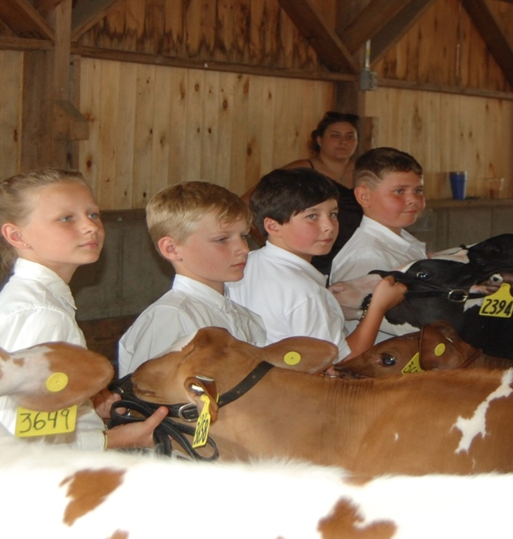
Class 22 - Dairy
- Read all fair rules and regulations before entering.
- Leather, nylon or rope halters are acceptable in all lots.

Record Book
Lot # Lot Description
RB-1 Novice Record Book (7-8 years old or 1st
year)
RB-2 Junior Record Book (9-13 years old)
RB-3 Senior Record Book (14-19 years old)

Fitting & Showmanship
Lot # Lot Description
FS-1 Novice (7-8 years old or 1st year)
FS-2 Junior (9-13 years old)
FS-3 Senior (14-19 years old)
FS-4 Over the Hill (adult competitors)
.
Breed Classes
- For the breed classes, choose the lot(s) you are entering and add the letter for the breed.
A – Ayrshire B - Brown Swiss
G - Guernsey H – Holstein
J – Jersey M - Milking Shorthorn
O – Other Breed
Lot # Lot Description Birthdate
1 Spring Calf 3/1/26 - 5/31/26
2 Winter Calf 12/1/25 - 2/28/26
3 Fall Calf 9/1/25 - 11/30/25
4 Summer Yearling 6/1/25 - 8/31/25
5 Spring Yearling 3/1/25 - 5/31/25
6 Winter Yearling 12/1/24 - 2/28/25
7 Fall Yearling 9/1/24 - 11/30/24

Top 2 in lots 1-7 will compete for Junior Champion & Reserve Junior Champion.

Lot # Lot Description Birthdate
8 2 year old 9/1/24 - 8/31/24
9 3 year old 9/1/22 - 8/31/23
10 4 year old 9/1/21 - 8/31/22
11 Aged Cow >9/1/21
12 Dry Cow Any Age
13 Best Udder Any Age in lactation
Top 2 in lots 8-12 will compete for Senior Champion & Reserve Senior Champion.
Junior Champion & Senior Champion from each breed will then compete for Grand Champion & Reserve Grand Champion.
Grand Champion & Reserve Grand Champion of each breed will then compete for Supreme & Reserve Supreme Champion.
Group Classes
Lot # Lot Description
14 Best 3 Females - 3 females, any age,
owned by a single exhibitor
15 Club Herd - 5 animals, any age, owned by
at least 3 exhibitors from the same club
16 Get of Sire - 3 daughters from 1 sire
17 Produce of Dam - 2 daughters from 1 dam
18 Daughter/Dam - 1 dam and 1 daughter
19 Obstacle Course
Class 23 - Beef
- Read all fair rules and regulations before entering.
Record Book
Lot # Lot Description
RB-1 Novice Record Book (7-8 years old or 1st
year)
RB-2 Junior Record Book (9-13 years old)
RB-3 Senior Record Book (14-19 years old)

Fitting & Showmanship
Lot # Lot Description
FS-1 Novice (7-8 years old or 1st year)
FS-2 Junior (9-13 years old)
FS-3 Senior (14-19 years old)
FS-4 Over the Hill

Breed Classes
For the breed classes, choose the lot(s) you are entering and add the letter for the breed.
- A – Angus
- H – Hereford
- AO – All other breeds
- X – Crossbred
Lot # Lot Description
1 Heifer <6 months
2 Heifer 6-12 months
3 Heifer – 1 year
4 Cow/calf - 2 years
5 Cow/calf - 3 years and over
6 Feeder calf steer
7 Market steer - to be divided by weight as
entries all and at the discretion of the
superintendent
8 Produce of dam (2 animals from 1 dam)
9 Get of Sire - 3 animals from 1 sire
10 Beef Herd - 3 animals shown by one
exhibitor
11 Club Herd - 4 animals, any age, owned by at
least 2 exhibitors from the same club
12 Obstacle Course

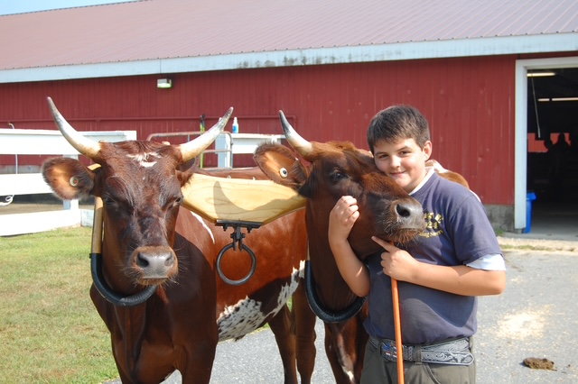
Class 24 - Working Steers
- Read all fair rules and regulations before entering.

Lot # Lot Description Record Books
RB-1 Novice Record Book (7-8 years old or 1st
year)
RB-2 Junior Record Book (9-13 years old)
RB-3 Senior Record Book (14-19 years old)
Classes
Lot # Lot Description
1 Novice ( 7-8 years old) or 1st Year
Showmanship
2 Junior Showmanship (9-13 years old)
3 Senior Showmanship (14-19 years old)
4 Over the Hill Showmanship
5 Junior Cart
6 Senior Cart
7 Junior Stone Boat
8 Senior Stone Boat
9 Junior Log Scoot
10 Senior Log Scoot
11 Obstacle Course

Class 25 - Goats
- Read all fair rules and regulations before entering.
- Classes are based on the goat’s age on the day of show, 7/25/2026
Lot # Lot Description Record Books
RB-1 Novice Record Book (7-8 years old or 1st year)
RB-2 Junior Record Book (9-13 years old)
RB-3 Senior Record Book (14-19 years old)

Fitting & Showmanship
Lot # Lot Description
FS-1 Novice (7-8 years old or 1st year)
FS-2 Junior (9-13 years old)
FS-3 Senior (14-19 years old)
FS-4 Over the Hill
Breed Classes
For the breed classes, choose the lot(s) you are entering and add the letter for the breed.
A - Alpine L - LaMancha
ND - Nigerian Dwarf N - Nubian
O - Obershall S - Saanen
T - Toggenburg AOP - All other purebreds
R - Recorded Grade/Crossbreed
Lot # Lot Description Birthdate
1 Junior Buck 0-3 months
2 Junior Doe A 0-3 months
3 Junior Doe B 3-6 months
4 Dry Yearling A. 6-12 months
5 Dry Yearling B 12-24 months
Top 3 does in lots 2-5 will compete for Grand, Reserve, and Honorable Mention Overall Junior.

6 Milker A 1-2 Year Old Milkers
7 Milker B 3-4 Year Old Milkers
8 Milker C 5+ Year Old Milkers
9 Dry Milker Any doe more than a year
old not in lactation
10 Best Udder Any age doe in lactation
Top 3 does in lots 6-9 will compete for Grand, Reserve, and Honorable Mention Overall Senior.
11 Daughter/Dam 1 dam and 1 daughter
12 Produce of Dam 2 daughters from 1 dam
13 Get of Sire 3 animals from 1 sire

Meat Goats

Lot # Lot Description

1 Buck under 4 months

2 Market Wether raised for meat

3 Junior Doe kid under 12 months

4 Senior Doe over 12 months

Champion Class (1st and 2nd place from Lots 1-4)

5 Dam and Daughter

6 Produce of Dam- Dam must be named

Pet Goats
Lot # Lot Description
14 Pet Goat Any age/sex
Not entered in any other division
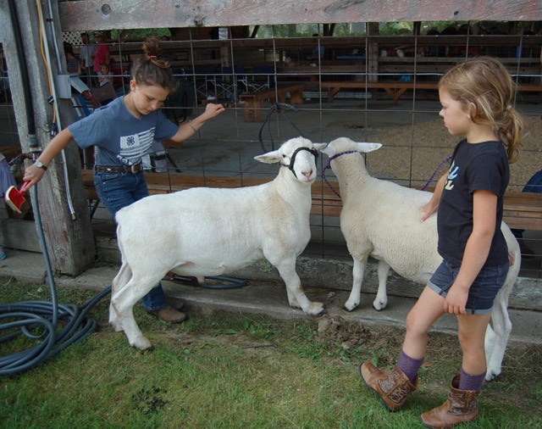

Class 26 - Sheep
- Read all fair rules and regulations before entering.
- All fitting done at the fairgrounds must be done by a 4-H member ONLY
- Showing on a halter is mandatory in novice classes.
- Market lambs cannot have been shown in breed classes.
- Any breed with 5 or more sheep exhibited by 2 or more 4- Hers will show separately. Breeds with fewer than the numbers stated will show in “All Other Breeds – Meat” or “All Other Breeds – Wool”.

Lot # Lot Description Record Books
RB-1 Novice Record Book (7-8 years old or 1st year)
RB-2 Junior Record Book (9-13 years old)
RB-3 Senior Record Book (14-19 years old)

Fitting & Showmanship
Lot # Lot Description
FS-1 Novice (7-8 years old or 1st year)
FS-2 Junior (9-13 years old)
FS-3 Senior (14-19 years old)
FS- 4 Over the Hill

Leadline
Lot # Lot Description
LL- 1 Novice (7-8 years old or 1st year)
LL-2 Junior Leadline
LL-3 Senior Leadline

Meat Breed Classes
Lot # Lot Description
M-1 Yearling Ram
M-2 Ram Lamb
M-3 Pair of Ram Lambs
M-4 Yearling Ewe
M-5 Ewe Lamb
M-6 Aged Ewe ( over 2 years old)
M-7 Pair of Ewe Lambs
M-8 Exhibitor’s Flock (2 ewes, 1 ram any age)

M-9 Set of Twins - Bred & Owned (papers will be
checked)
M-10 Pen of 3 lambs – Bred & Owned (both sexes
represented)
M-11 Get of Sire – Bred & Owned (3 lambs from one
ram)
M-12 Obstacle Course
Wool Breed Classes
Lot # Lot Description
W-1 Yearling Ram
W-2 Ram Lamb
W-3 Pair of Ram Lambs
W-4 Yearling Ewe
W-5 Ewe Lamb
W-6 Aged Ewe (over 2 years old)
W-7 Pair of Ewe Lambs
W-8 Exhibitor’s Flock (2 Ewes, 1 Ram any age)
W-9 Set of Twins- Bred & Owned (papers will be checked)
W-10 Pen of 3 Lambs- Bred & Owned (both sexes
represented)
W-11 Get of Sire - Bred & Owned (3 lambs from
one ram)
W-12 Best Fleece
W-13 Obstacle Course

Market Classes
Lot # Lot Description
1 Market Lambs (divided by weight)
2 Obstacle Course

Class 27 – Poultry/ Waterfowl
- Read all fair rules and regulations before entering.
- Waterfowl are not allowed to be shown or displayed for the 2026 show season

All entries must be a true representation of their breed.
- All single entries; no pairs or trios.
- Unhealthy animals will be refused entry.
- All state health regulations must be followed.
- See livestock rules for a complete list of CT Fair Regulations.
- Exhibitors are responsible for bringing their own equipment, including feed & water dishes.
- All equipment must be in good working order.
- Exhibitors are also responsible for care of animals & exhibit area.
- Exhibitors will be limited to three entries of each breed per lot.
Record Book
Lot # Lot Description
RB-1 Novice Record Book (7-8 years old or 1st year)
RB-2 Junior Record Book (9-13 years old)
RB-3 Senior Record Book (14-19 years old)

Fitting & Showmanship
Lot # Lot Description
FS-1 Novice (7-8 years old or 1st year)
FS-2 Junior (9-13 years old)
FS-3 Senior (14-19 years old)
FS-4 Over the Hill
Type Classes
Lot # Lot Description
5 Standard Poultry - Cockerel/Cock
6 Standard Poultry - Pullet/Hen
7 Bantam - Cockerel/Cock
8 Bantam - Pullet/Hen
9 Waterfowl
10 Production Birds - Cockerel/Cock
11 Production Birds-Pullet/Hen

Class 28 – Pets
- Read all fair rules and regulations before entering.
- Lots will be divided by species as determined by the superintendent on the day of the show. Lots may be combined or removed as necessary.

Record Book
Lot # Lot Description
RB-1 Novice Record Book (7-8 years old or 1st year)
RB-2 Junior Record Book (9-13 years old)
RB-3 Senior Record Book (14-19 years old)
Fitting & Showmanship
Lot # Lot Description
FS-1 Novice (7-8 years old & First Time
Showing)
FS-2 Junior (9-13 years old)
FS-3 Senior (14-19 years old)
FS-4 Over the Hill

Class 29 – Rabbits & Guinea Pigs
Read all fair rules and regulations before entering.
Record Book
Lot # Lot Description
RB-1 Novice Record Book (7-8 years old or 1st year)
RB-2 Junior Record Book (9-13 years old)
RB-3 Senior Record Book (14-19 years old)

Fitting & Showmanship
Lot # Lot Description
FS-1 Novice (7-8 years old & First Time
Showing)
FS-2 Junior (9-13 years old)
FS-3 Senior (14-19 years old)
FS-4 Over the Hill

Rabbit Breed Classes
Lot # Lot Description
1 Purebred Doe- Junior under 6 months
2 Purebred Buck- Junior under 6 months
3 Purebred Doe-Senior over 6 months
4 Purebred Buck- Senior over 6 months
5 Grade Doe- Junior under 6 months
6 Grade Buck- Junior under 6 months
7 Grade Doe- Senior over 6 months
8 Grade Buck- Senior over 6 months
9 Market Doe
10 Market Buck

Guinea Pig Breed Classes
Lot # Lot Description
1 Any boar
2 Any sow

Class 30 - Swine
Read all fair rules and regulations before entering.
Record Book
Lot # Lot Description
RB-1 Novice Record Book (7-8 years old or 1st year)
RB-2 Junior Record Book (9-13 years old)
RB-3 Senior Record Book (14-19 years old)

Fitting & Showmanship
Lot # Lot Description
FS-1 Novice (7-8 years old or 1st year)
FS-2 Junior (9-13 years old)
FS-3 Senior (14-19 years old)
FS-4 Over the Hill

Market Hogs
Lot # Lot Description
1 Light Weight Market Hog, 75-150 lbs.
2 Medium Weight Market Hog, 151-225
lbs.
3 Heavy Weight Market Hog, 226-300
lbs.
4 Boar, 3 - 6 months
5 Boar, 6 months - 1 year
6 Gilt, 3 - 6 months
7 Gilt, 6 months - 1 year
8 Gilt or Sow, 1 year - 2 years
9 Feeder pig, weaned to 75 lbs.

Class 31 - Horses

Read all fair rules and regulations before entering.

Record Book
Lot # Lot Description
RB-1 Novice Record Book (7-8 years old or 1st year)
RB-2 Junior Record Book (9-13 years old)
RB-3 Senior Record Book (14-19 years old)
Showmanship
Lot # Lot Description
S-1 Novice (7-8 years old & First Time
Showing)
S-2 Junior (9-13 years old)
S-3 Senior (14-19 years old)
S-4 Over the Hill

In Hand Classes
H-1 In Hand Suitability
H-2 In Hand Pleasure
H-3 In Hand Disciplined Rail

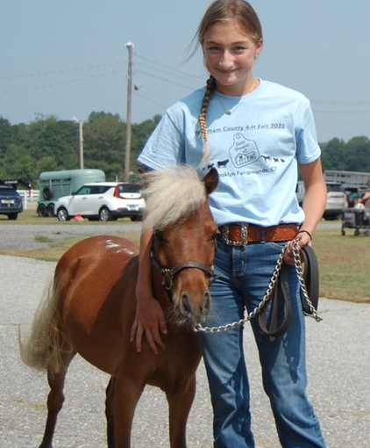

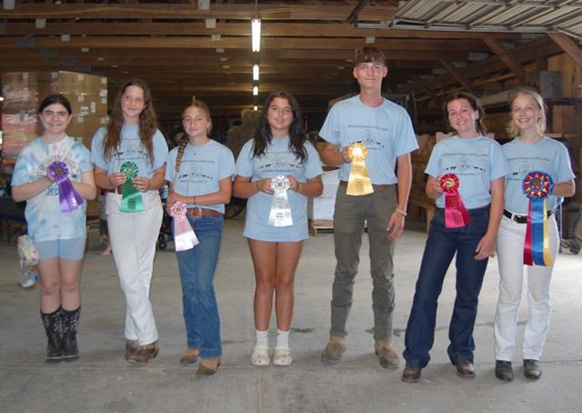

Premier Showmanship
- The top overall showman from each livestock division will compete for Premier Showman.
- “Out of County” Exhibitors are not eligible.
- If you have won premier showmanship in a previous year, you are no longer eligible to compete.
- Each participant will compete with each available animal species. Animals will be assigned at random by the Premier Showmanship Committee.
- Learning how to show each of the species is the responsibility of the participants.
- Participants may not show their own animals in premier showmanship, unless there is no other available animal.
- Fitting of the animal will not be evaluated, although the animal is expected to be clean.

All participants will be evaluated by the same judge(s) using the following points system for each animal shown:
Appearance of Exhibitor (Fair T-shirt & show pants) 10 pts.
Posing & Showing of Animal 15 pts.
Shows Animal to Best Advantage 15 pts.
Exhibitor’s poise, attentiveness, courtesy to judge(s) and other exhibitors & patience 10 pts.
Total per animal 50 pts.

Livestock Herdsmanship Contest
- All exhibitors of livestock and small animals will be entered. Individual herdsmanship awards will be given to individual 4-H members or those whose club does not include the species being shown. Exhibitors must indicate on their entry forms which category they wish to enter.
- Awards will be given out at the closing ceremonies Sunday afternoon. The name of the winning 4-H club/individual in each category will be engraved on a perpetual plaque. Clubs are encouraged to set up club “barn duty” schedules.
- Judging begins upon arrival at the grounds and ends at departure time on Sunday when the awards will be presented.
Purposes:
- To maintain an attractive, well-managed livestock exhibit.
- To promote safety practices and proper handling of livestock.
- To inform and teach the public about livestock.
- To recognize cooperation and good sportsmanship
Lot # Lot Description
Club Large Animal
Individual Large Animal
Club Small Animal
Individual Small Animal

Large Animals are : Dairy Cattle, Beef Cattle, Working
Steers and Horses.

Small Animals are: Sheep, Goats, Rabbits and Poultry.

Be Sure to Enter in the 10th Annual Obstacle Course
One entry per member.
Your animal has to walk through the course on its own power. No carrying of your animal.
We encourage borrowing an animal from another 4-H member.
Entries will be split as follows;
Livestock – dairy cattle, beef cattle, working steers, sheep, goats and horses

Don’t Miss the 13th Annual Costume Contest!
- Open to all livestock exhibitors. One entry per member, per division.
- Entries will be split as follows;
Large Livestock – dairy cattle, beef cattle, working steers, sheep, goats and horses
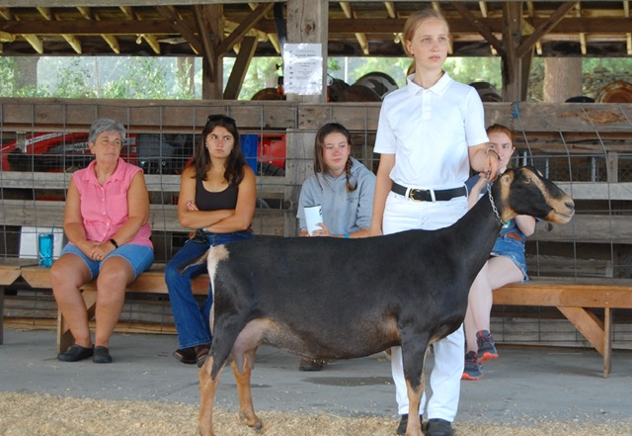
Small Livestock – dogs, rabbits, small animals, and poultry.

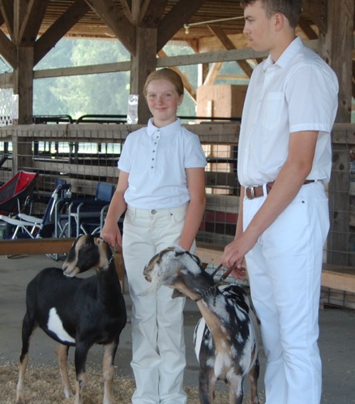

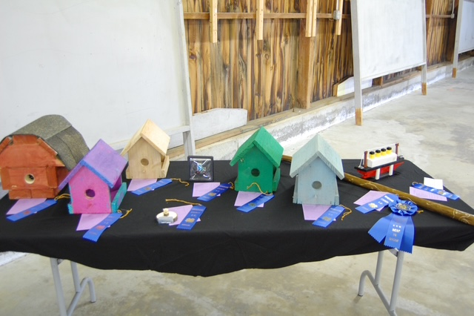


Windham County 4-H Fair

Battle of the Barns

Saturday, July 25, 2026
8:00 p.m.

Join us for some fun as we play crazy and fun games in the Better Living Building! There is always lots of fun and laughs at this event whether we are shucking corn, competing in a tic tac toe relay race, or playing real life hungry hippos. Come join us to see what kinds of fun activities we have planned for this year!
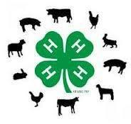

Windham County 4-H Fair

NON-ANIMAL Entry Form - Use one form for all non-animal entries.
Entries are due July 15, 2026
All exhibitors must turn in a Record Book.

Member Name:_____________________________________________________________________________

Address:__________________________________________________________________________________

Phone #:____________________________________ 4-H Age:______________________________________

Email:_____________________________________ Club Name:___________________________________
Fair Year:__________________________________

Class | Lot | Lot Description

I hereby agree to accept and abide by the rules of the Fair. I further agree not to hold the Windham County 4-H Fair Association responsible for any accident, injury or damage that may occur to any animal, project, person or property.

Exhibitor’s Signature:__________________________________________________________________

I also give permission for my child to be transported and treated by medical personnel if deemed necessary.

Parent’s Signature:___________________________________________________________________

All Fair Entries are due
July 15, 2026

Home Show and Animal Entries

Overnight Applications

Camping Registration

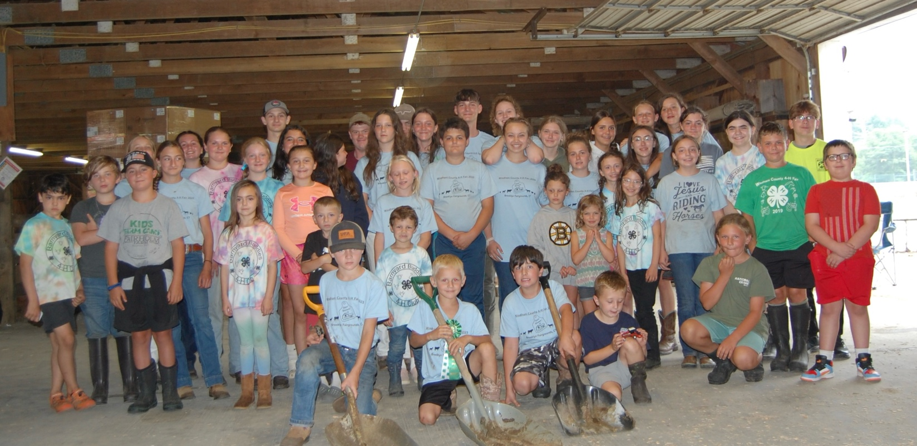

Windham County 4-H Fair
ANIMAL Entry Form
Entries are due July 15, 2026

Member Name:_____________________________________________________________________________

Address:__________________________________________________________________________________

Phone #:_______________________________________ 4-H Age:__________________________________

Email:________________________________________ Club Name:_________________________________

I am entering the herdsmanship contest (circle one): as an individual with my club

One animal per line; group each animal’s entries together. For daughter/dam, produce of dam & get of sire classes only enter the dam/sire.
*All exhibitors must compete in a Fitting & Showmanship class. All showmanship animals must also compete in at least one non-showmanship class.
Class | Lot | Lot Description | Animal’s Name/ID | Breed | D.O.B.
 |  | Fitting & Showmanship
 |  | Record Book

OVERNIGHT APPLICATION
THIS FORM IS DUE TO THE 4-H OFFICE, before JULY 15, 2026
Please submit this form and a completed 4-H Medical Form
Any 4-H member age 12 and older by the time of the fair may stay overnight on the fairgrounds to care for livestock exhibits. Younger members may stay if accompanied by his/her own parent/guardian.
All overnight exhibitors must agree to the following rules
- Exhibitor must be supervised by an adult from his/her own club who agrees to that role. There must be one adult staying overnight for every six 4-H members.
- Agrees to follow rules set by adult chaperones.
- Exhibitor must arrive at the fairgrounds by 8:00 pm to stay the night and agree to stay on the fairgrounds for the remainder of the night.
- Curfew will be set by the adult chaperones and will be enforced by the Overnight Director. At curfew all overnight exhibitors must be in the barn or sleeping area
- Exhibitors must be in good health and require no special care.
4-H Member _________________________________________________________ Age ______________________

Address ________________________________________________________________________________________

Parent’s Name ___________________________________________________________________________________

Phone __________________________________________________________________________________________

Alternate Emergency Contact
Name __________________________________________________________________________________________

Phone __________________________________________________________________________________________

Relationship to 4-Her _______________________________________________________________________________

By signing below, I agree to abide by the outline rules.

4-H Member Signature ______________________________________________________________________________

I give my son/daughter permission to stay overnight at the WIndham County 4-H Fair during the times of the 4-H Fair. If I am not staying overnight and cannot be reached, I hereby give my permission for him/her to be transported and receive medical treatment in an emergency.
Parent/Guardian Signature ____________________________________________________________________________

Date ______________________________________________________________________________________________
The overnight adult responsible for this 4-Her must complete and sign this section:
Adult Supervisor’s Name (printed) ______________________________________________________________________

Adult Supervisor’s Signature ___________________________________________________________________________

Date ____________________________________ Phone ____________________________________________________

Class #22
Outstanding Artisan Award

Exhibitors must enter in at least 7 of the following classes:

- 3 - Poster
- 5 - Baked Goods
- 6 - Canning/Food Preservation
- 7 – Eggs
- 8 - Non-Animal Products
- 9 – Flowers 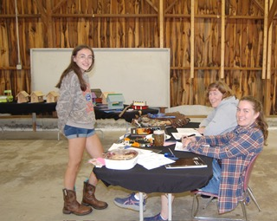
- 10 - Horticulture
- 11 - Needlework
- 12 - Clothing and Sewing
- 13 - Artwork
- 14 - Photography
- 15 - Collections
- 16 - Scrapbooks
- 17 - Hobbies and Crafts
- 18 - Model Building and Rockets
- 19 - Woodworking and Electrical

Each entry will be judged in its individual classes at the regular time of judging. The seven entries of your choice will be presented by the 4-Her and judged as a group beginning at 8:00 a.m. on Sunday.
Member/Volunteer Information (This form is used to ensure your safety and well being.)
Last Name | First |  |  | Middle Initial |  |  | - M ❑ F  Sex | / /  Date of Birth
Street Address | City |  | State |  | ZIP Code |  |  | ( )  Home Phone No.
Notify in Case of Emergency (Emergency Contacts will be notified in order listed until one contact is reached)
Name Relationship | Name Relationship
Address | Address
City State Zip Code | City State Zip Code
( ) ( ) ( )  Home Telephone Work Telephone Cell Telephone | ( ) ( ) ( )  Home Telephone Work Telephone Cell Telephone
Allergies
Food (List Food) |  | Life Threatening? |  |  |  | - Yes |  | - No
Drug (List Drug) |  | Life Threatening? |  |  |  | - Yes |  | - No
Insect (List Insect) |  | Life Threatening? |  |  |  | - Yes |  | - No
Other (List) |  | Life Threatening? |  |  |  | - Yes |  | - No
Personal Medical History
Previous Surgery/Hospitalization? Explain |  |  |  |  |  |  |  | Date
Physical Impairment? Explain |  |  |  |  |  |  |  | Date
Mental Health Issues Requiring Treatment? Explain |  |  |  |  |  |  |  | Date
Current Medications and conditions for which they are prescribed? |  |  |  |  |  |  |  | Date
Is there any other personal medical history you feel we should know? |  |  |  |  |  |  |  | Date
Parent/Guardian Authorizations:
I recognize that some activities have an inherent risk that could result in personal injury. The person herein described has permission to engage in all 4-H activities except as noted. Please list here:

I hereby give permission to the medical personnel to order x-rays, routine tests, treatment; to release any records necessary for insurance purposes; and to provide or arrange necessary related transportation for me or my child. In the event that I cannot be reached in an emergency, I hereby give permission to the physician selected to secure and administer treatment, including hospitalization, for the person named above. I (we) understand that all financial obligations incurred, if not covered by insurance, will be my responsibility. This form may be photocopied for specific special events such as sledding trips, project workshops, etc. This health form will be maintained in a confidential manner.
Printed Name |  |  |  |  |  |  |  | Date

Parent/Guardian Authorizations Continued
I, , affirm that due to my and/or my child’s sincere religious beliefs, I/my child may not receive the following medical treatment:

_____ Certain treatment (specify):

_________________________________________________________________________________________________________________________________________________________________________________________________________________

--
_________________________________________________________________________________________________________________________________________________________________________________________________________________

_
___________________________________________________________________________________________________________________________________________________________________________________________________________________

_____ Any Medical Treatment

I release the University of Connecticut, its Cooperative Extension System, 4-H Youth Development Program, the State of Connecticut and their agents and employees from any responsibility or impairment to me/my child’s health that may result from this exemption.

Signature of Parent or Guardian Date:
Printed Name
If your son, daughter or ward will be under the age of 18 while in attendance at this 4-H overnight
Event, it is the University of Connecticut 4-H Program policy to secure your consent for medication distribution and for the use of medical devices. The medication or medical device can be self-administered or be administered by the on-site nurse/health professional.

All medications must be in a medicine bottle and labeled with the participant’s name, doctor’s name and phone number, medication name, and dosage. You must also complete the form below:

_ _No medication has been brought to the 4-H overnight event.

_ I want the medication or medical devices self administered. (Age 14 and above only.)

_ I want the medication or medical device administered by the Nurse/Health Professional However, a limited amount of medication for life threatening conditions may be carried by my son/daughter/ward. (i.e. bee sting kits, inhalers)

Name of medication(s) Prescribing Doctor Doctor’s phone number

Amount to be taken How is it taken? When to be administered

Day(s) to be taken Special Instructions

Camping Registration Form
Please send the completed form by July 15, 2026

Name of Adult Chaperone:_____________________________________________________

Complete Mailing Address:_________________________________________________

Cell:______________________________

Will you be using electricity? YES NO

Camper License Plate#:___________________________________

I hereby agree to accept and abide by the rules of the Windham County 4-H Fair. I further agree not to hold the Windham County 4-H Fair Association responsible for any accident, injury or damage that may occur to any animal, person or property.

Signature of Adult:_______________________________________________
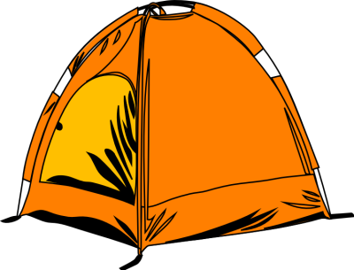
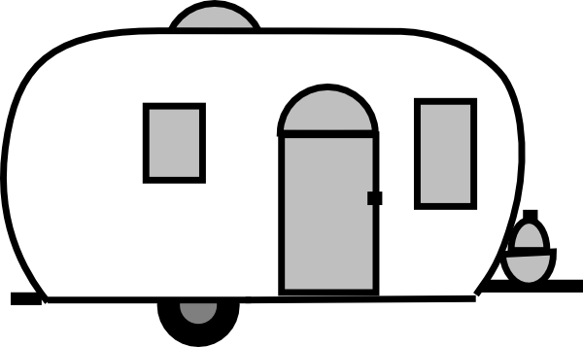

Upcoming Events in
Windham County

- August 6, 2026 - Next Windham County 4-H Fair Meeting - Help your fellow
4-Hers plan next year’s fair!
- September 19, 2026 - 4-H Day at the Big E
- November 21, 2026 - Recognition Night (county awards, potluck dinner & square dancing - open to all Windham County 4-H members and families)
- January 2027 - Windham County Food Show (contact office to sign club up)
- February 2027 - Public Speaking (write and present about a topic of your choice)


Be a part of planning next year’s fair! All 4-Hers are welcome to join the Windham County 4-H Fair Association. We meet on the second Thursday of the month at 6:30 p.m., located at the Windham County Extension Center in Brooklyn, CT.

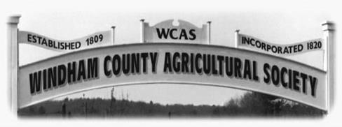
The Windham County
4-H Fair Association would like to extend a very special word of thanks to the Windham County Agricultural Society for their many years of service and support.

