UConn 4-H Poultry Project at the Big E

Please review all information about the Big E 4-H Poultry Show prior to applying.

Applicants: Send or drop off this application to your county 4-H office by August 1, 2026.

Applicants must be at least 12 years of age as of January 1, 2026, and a 4-H member in the poultry project for a minimum of 2 years (verified by 2 years of verification forms submitted with application). Please read the Big E 4-H Poultry Show guidelines to ensure you are ready for this program.

The top 10 Exhibitors (with birds) and 4 Junior Leaders (without birds) will be selected, and additional members will be placed on an alternates list. All applicants will be notified by August 18, 2026.

If accepted, a mandatory in-person orientation meeting with a parent/guardian will be held on August 20, 2026 at 6:00 pm at the Hartford County 4-H office in Farmington.

When completing this application, please be mindful of the UConn 4-H Artificial Intelligence Guidelines.

Leaders: Please complete the evaluation section and send it to your county 4-H office (must be received by August 1, 2026).

Timeline:
4-H members, parents, and leaders: Pay special attention to the application components in the highlighted cells.
What is due? | When is it due? | Who does it?
UConn 4-H Poultry Project at the Big E Application  This packet! This application will be used to determine who will qualify to represent CT at Big E. There is still another Big E application deadline (see below). | 8/1/26 | 4-H Members, and Leaders
Photo of bird, coop tag, and ribbon (blue/red) at 4-H fair, emailed | ASAP preferred or by 8/16/26 | 4-H Member and/or parent
Notification to Applicants via email | 8/18/26 | UConn 4-H Poultry Committee
Big E Application due to Big E (Page 3 of this document) ShoWorks Entries | 8/21/26 | 4-H Member and Parents
Orientation | 8/26/26 | UConn 4-H Poultry Committee hosts and 4-H members and parents attend.
Dorm Roster | 8/31/26 | UConn 4-H Poultry Committee
Tickets and Parking Passes | Mailed to 4-H members the week before the show. | UConn 4-H Poultry Committee
Release of Poultry | 9/21/26 at 5:00 pm | 4-H Members and Parents

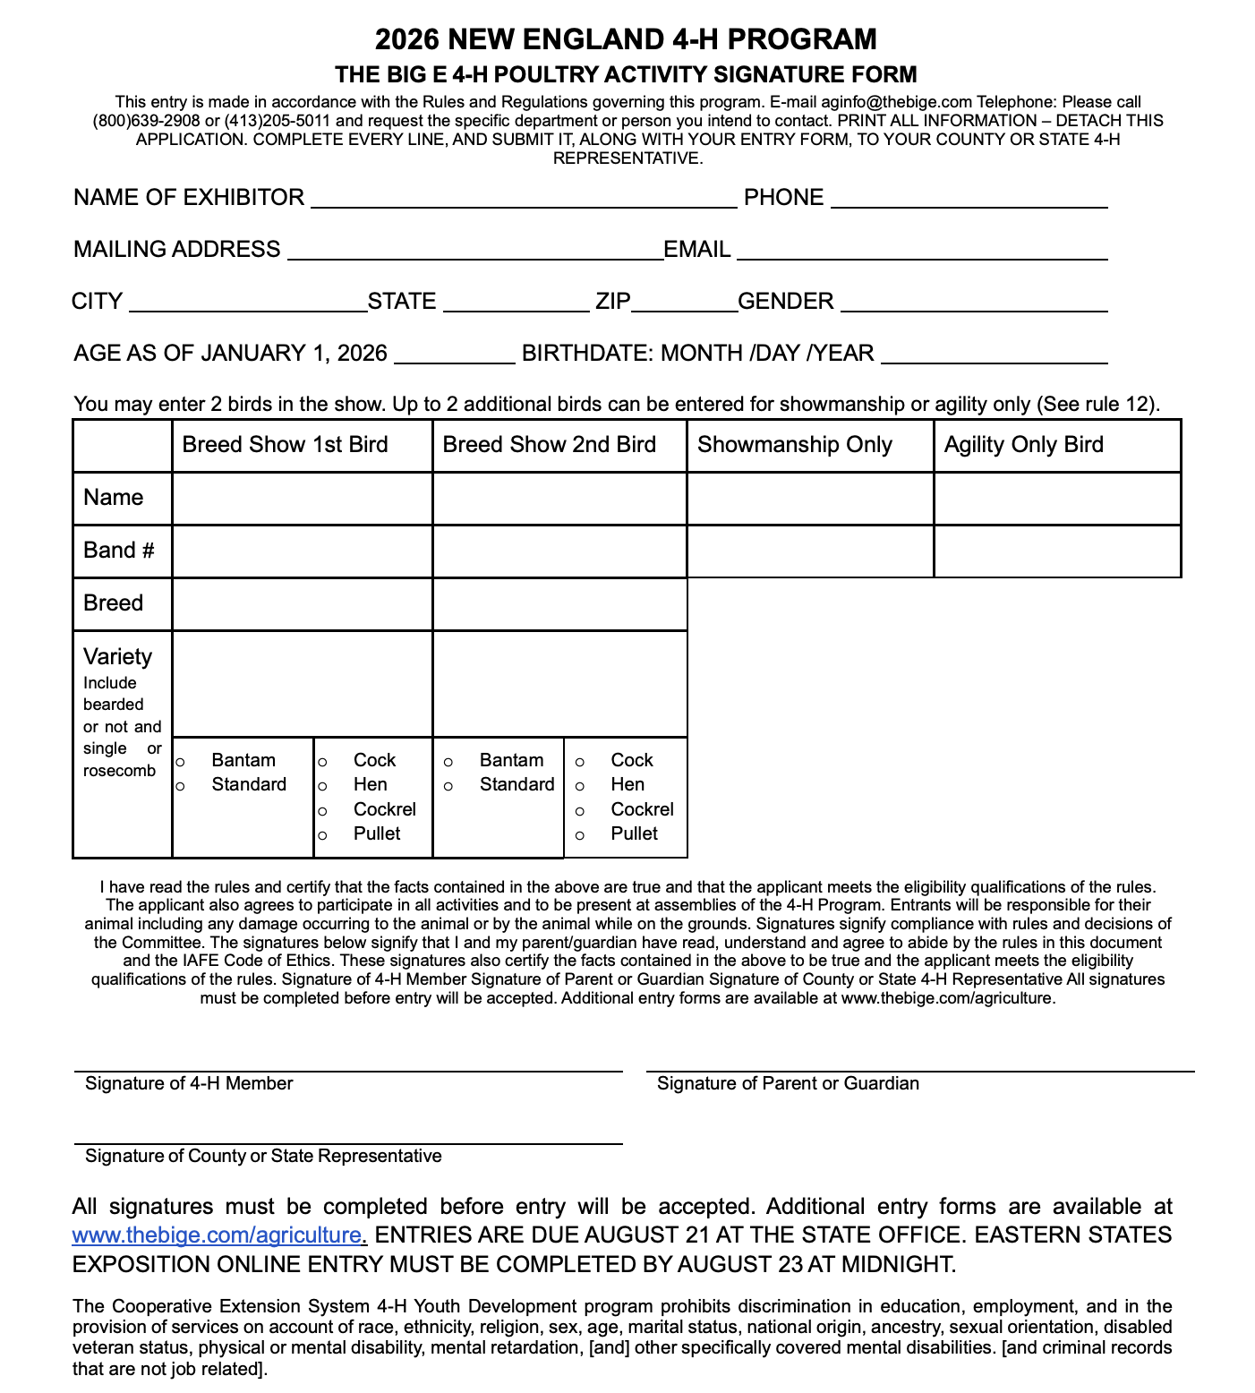

UConn Big E 4-H Poultry Program Exhibitor Application

Name: ____________________________________ Years as a 4-H Club Member: ________________

Club: ___________________________________ County: ___________________________________

Home Phone Number: _________________________ Cell Number: ___________________________

Parent/Guardian 1 Name: _________________________ Cell: _________________________

Email: __________________________________

Parent/Guardian 2 Name: _________________________ Cell: _________________________

Email: __________________________________

Check one: ____ 1st yr. Exhibitor ____ 2nd yr. Exhibitor ____ 3rd yr. or more Exhibitor

____ 1st yr. Junior Leader ____ 2nd yr. Junior Leader ____ 3rd yr. or more Junior Leader

Date(s) as previous Exhibitor/Junior Leader: ___________________________________

Tip: Level could mean participation at either the Club, County, State, Regional, or National.

Project Participation: List the years and activities you have participated in the 4-H Poultry Project on the county, state or regional level. Use additional paper as needed.
Year | Level | Activity Description

Tell us about your 4-H Poultry Project for this year.

Awards: List any awards you have won in any/all county UConn 4-H Poultry or other sanctioned Poultry Shows.
Year | Level | Activity Description

Leadership: List any club, fair, county or state leadership role you have held. Please list each with the date held.
Date | Leadership Role | Club, Fair, etc. | Level

Volunteerism: List times when you have volunteered in or outside of the poultry project.
Date | Level | Community Service Description

Public Speaking: List demonstrations, public speeches, presentations, etc. you have given in or outside of 4-H.
Date | Level | Description

4-H Involvement: List all other 4-H county or state activities/events you have attended in the last two years. Please note your participation level (i.e., planning committee, participant, etc.) and the dates of the event.
Date | Level | Activity Description

Short Answer: Why do you want to participate in the Big E 4-H Poultry Program?

Additional Attachments: Please attach the following to your application.
- Verification Forms: Please include a copy of 2 years of poultry verification forms.
- Photo of Bird, Coop Tag, and Ribbon from 4-H Fair

After applications have been submitted, you will still need to show your bird at a UConn 4-H Fair and place a blue or a red in either breed or showmanship.

Email photo that shows the bird, coop tag, and ribbon to fairfield@uconn.edu ASAP or by 8/16/26.

Example photo is made with AI, but includes info we need to see in your photo.
- Bird
- Coop Tag with Judges Placing (must indicate 1 or 2, blue or red ribbon/sticker to qualify).

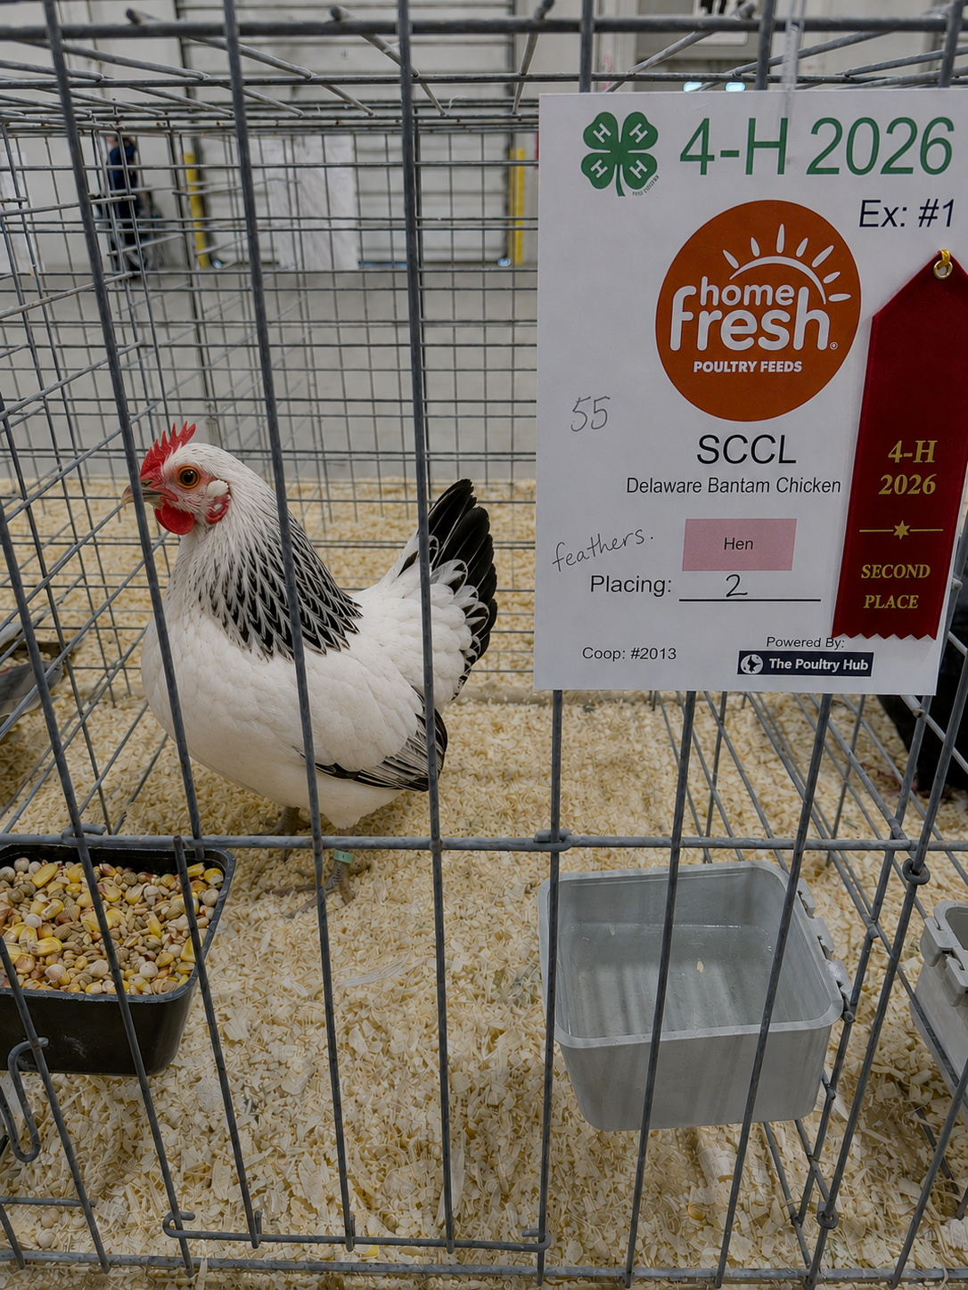
After you submit your photo, the UConn 4-H Poultry Committee will review the photo and notify applicants if they are qualified.

______________________________________ ___________________
Applicant’s Signature Date

______________________________________ ___________________
Parent or Guardian’s Signature Date

Leader Recommendation

Applicants do not see this evaluation. Please use additional paper as needed.

Please submit the completed application to fairfield@uconn.edu.

Applicant Name: _____________________________________

In your opinion, should this applicant represent UConn 4-H at the Big E in the Poultry Project area?
__ Yes ___ No

Why or why not?

Rank the applicant on a scale of 1-5 (1 being lowest and 5 being highest).

Readiness to serve as an exhibitor. | 1 | 2 | 3 | 4 | 5
Readiness to serve as a junior leader. | 1 | 2 | 3 | 4 | 5
Leadership ability. | 1 | 2 | 3 | 4 | 5
Ability to follow directions. | 1 | 2 | 3 | 4 | 5
Time management skills. | 1 | 2 | 3 | 4 | 5
Ability to care for their animal independently. | 1 | 2 | 3 | 4 | 5
Maturity | 1 | 2 | 3 | 4 | 5
Project knowledge. | 1 | 2 | 3 | 4 | 5
Ability to meet expectations of the Big E 4-H Poultry program. | 1 | 2 | 3 | 4 | 5

Please list the applicant’s strengths:

Please list areas where the applicant can grow:

________________________________________ _______________
Leader Signature Date

UConn 4-H Big E Poultry Program Exhibitor Selection Process: Cover Sheet
Office Use Only

Applicant’s Name: _____________________________________ Accepted: Yes No

Notification sent: ________

Done? | What is due? | When is it due? | Who does it?
 | UConn 4-H Poultry Project at the Big E Application (this one) | 8/1/26 | 4-H Members and Leaders
 | 4-H fair photo of bird, coop tag, and ribbon (blue/red), emailed | ASAP preferred  Or by 8/16/26 | 4-H Member and/or parent
 | Notification to Applicants via email | 8/18/26 | UConn 4-H Poultry Committee
 | ShoWorks Entries | 8/23/26 | 4-H Parents
 | Orientation | 8/20/26 | UConn 4-H Poultry Committee
 | Dorm Roster | 8/31/26 | UConn 4-H Poultry Committee
 | Tickets and Parking Passes | Mailed to 4-H members the week before the show. | UConn 4-H Poultry Committee
 | Release of Poultry | 9/21/26 at 5:00 pm | 4-H Members and Parents

Strengths of Application

Opportunities to strengthen application for next time:

The University of Connecticut complies with all applicable federal and state laws regarding non-discrimination, equal opportunity and affirmative action, including the provision of reasonable accommodations for persons with disabilities. Extension program participants with disabilities may request reasonable accommodations to address limitations resulting from a disability. For more information, please contact the UConn Extension Civil Rights Liaison at extensioncivilrights@uconn.edu

Draft:
Orientation

Bring with you:
- UConn 4-H Health Form (please make sure it is up to date).
- Verification and lease forms
- Signed ESE Photo Release

The University of Connecticut complies with all applicable federal and state laws regarding non-discrimination, equal opportunity and affirmative action, including the provision of reasonable accommodations for persons with disabilities. Extension program participants with disabilities may request reasonable accommodations to address limitations resulting from a disability. For more information, please contact the UConn Extension Civil Rights Liaison at extensioncivilrights@uconn.edu

